SC201(1900A/1903A)
Computer-controlled, High-speed,Bartacking Machine
Version：2010-01

Foreword
Thank you for using our Computerized Control System for Special Sewing Machine.
It is appreciated that you do read this manual carefully in order to operate the machine correctly and effectively. If the user operates the machine contrary to regulations herein, thus cause loss to user or third party, we will not take responsibility. Besides, you should keep this manual for future use. For any fault or problem of machine, please ask the professionals or the technicians authorized by us for repair service.
Safety Matters for Attention
- Signs & Definitions of Safety Marks
This User’s Manual and the Safety Marks printed on the products are to enable you to use this product correctly so as to be away from personal injury. The signs and definitions of Marks are shown in below:
Danger | The incorrect operation due to negligence will cause the serious personal injury or even death.
Caution | The incorrect operation due to negligence will cause the personal injury and the damage of mechanism.
 | This kind of marks is “Matters for Attention”, and the figure inside the triangle is the content for attention. (Exp. The left figure is “Watch Your Hand!”)
 | This kind of mark is “Forbidden”.
 | This kind of mark means “Must”. The figure in the circle is the contents that have to be done. (Exp. The left figure is “Ground!”)
- Safety Matters for Attention
Danger
 | For opening the control box, please turn off the power and take away the plug from socket firstly, and then wait for at least 5 minutes before opening the control box. Touching the part with high voltage will cause the person injury.
Caution
Usage Environment
 | Try not to use this sewing machine near the sources of strong disturbance like high-frequency welding machine.  The source of strong disturbance will affect the normal operation of the sewing machine.
The voltage fluctuation shall be within 20% of the rated voltage.
The large fluctuation of voltage will affect the normal operations of sewing machine, Therefore a voltage regulator is needed in that situation.
Working temperature: 5℃~35℃.
The operation of the sewing machine will be affacted by environment with temperature beyond the above range.
 | Relative Humidity: 45%~85%(No dew inside the machine), or the operation of sewing machine will be affected.
 | The supply of compressed gas shall be over the consumption required by the sewing machine. The insufficient supply of compressed gas will lead to the abnormal action of sewing machine.
 | In case of thunder, lightning or storm, please turn off the power and pull plug out the socket. Because these will have influence on the operation of sewing machine.
Installation
 | Please ask the trained technicians to install the sewing machine.
Don’t connect machine to power supply until the installation is finished.
Otherwise the action of sewing machine may cause personal injury once the start switch is pressed at that situation by mistake.
 | When you tilt or erect the head of sewing machine, please use both of your hand in that operation. And never press the sewing machine with strength.  If the sewing machine loses its balance, it will fall into floor thus causes the personal injury or mechanical damage.
 | Grounding is a must.  If the grounding cable is not fixed, it may cause the electric-shock and mis-operation of machine
 | The entire cables shall be fixed with a distance at 25mm away from the moving component at least. By the way, don’t excessively bend or tightly fixed the cable with nails or clamps, or it may cause the fire or electric shock.
 | Please add security cover on the machine head.

Sewing
This sewing machine can only be used by the trained staff.
This sewing machine has no other usages but the sewing.
When operating the sewing machine, please remember to put on the glasses. Otherwise, the broken needle will cause the personal injury in case the needle is broken.
At following circumstances, please cut off the power at once so as to avoid the personal injury caused by the mis-operation of start switch:
1.Threading on needles; 2. Replacement of needles; 3. The sewing machine is left unused or beyond supervision
At working, don’t touch or lean anything on the moving components, because both of the above behaviors will cause the personal injury or the damage of the sewing machine.
During working, if the mis-operation happens or the abnormal noise or smell is found at the sewing machine, user shall cut off the power at once, and then contact the trained technicians or the supplier of that machine for solution.
For any trouble, please contact the trained technicians or the supplier of that machine.
Maintenance & Inspection
Only can the trained technicians perform the repair, maintenance and inspection of this sewing machine.
For the repair, maintenance and inspection of the electrical component, please contact the professionals at the manufacturer of control system in time.
At following circumstances, please cut off the power and pull off the plug at once so as to avoid the personal injury caused by the mis-operation of start switch:.
1.Repair, adjustment and inspection ;
2.Replacement of the component like curve needle, knife and so on
Before the inspection, adjustment or repair of any gas-driven devices, user shall cut off the gas supply till the pressure indicator falls to 0.
When adjusting the devices needing the power supply and gas supply, users can’ t be too careful to follow the entire Safety Matters for Attention.
If the sewing machine damages due to the unauthorized modification, our company will not be responsible for it.

Contents
1. General Instruction 1
1.1 Specifications of SC201 1
1.2 Corresponding Machine Type 2
1.3 Input Mode 2
1.4 Display Method 2
1.5 Arrangement of the Panel 2
1.6 Standardization 2
1.7 Operation Mode 2
2. Operation Instruction 3
2.1 Instructions of the Panel 3
2.2 Installing the Main Motor 4
2.3 Test Mode 6
2.3.1 CP-1 (Input Signal Check) 8
2.3.2 CP-2 (Origin Retrieval) 10
2.3.3 CP-3 (Continuous Operation) 10
2.3.4 CP-4 (Revolution Movement) 11
2.3.5 CP-6 (Presser and Trimming Motor / Origin Sensor Check) 12
2.3.6 CP-7 (Thread Clamp Motor / Origin Sensor Check) 13
2.4 Operation of the Sewing Machine (Basic) 14
2.4.1 Item Data Setting 14
2.4.2 Checking the Contour of a Sewing Pattern 16
2.4.3 Sewing 17
2.4.4 Change to Other Sewing Pattern 18
2.4.5 Winding a Bobbin 18
2.4.6 Thread Clamp Device 19
2.4.7 Bobbin Thread Counter 21
2.4.8 Temporary Stop 21
2.4.9 Setting the Pattern Thread Tension 22
2.4.10 Table of the Standard Patterns 22
2.5 Operations of P Pattern and C Pattern 24
2.5.1 Perform Sewing Using the Pattern Key（） 24
2.5.2 Perform Sewing Using the Combination Function 28
2.6 How to Use the Memory Switch (User Class) 31
2.6.1 Start and Change of the Memory Switch 31
2.6.2 Example of the Memory Switch Setting 32
2.6.3 Table of Functions of the User Class Memory Switch 36
3. Memory Switch (Service Class) 40
3.1 Start and Change of the Memory Switch (Service Class) 40
3.2 Table of Functions of the Service Class Memory Switch 40
3.3 Restore Default Setting 41
4. Lockstitch Button Sewing Function 45
4.1 Lockstitch Button Sewing Function Setting 45
4.2 Table of the Lockstitch Button Sewing Patterns 46
5. Update the Pattern Data by USB Flash 48
5.1 Pattern Data Update 48
6 Appendix 1 52
6.1 Error List 52
7 Appendix 2 55
7.1 Installation Size of Control Box 55
7.2 Installation Size of Operation Box 56
7.3 Diagram of Connection of the External Cable and Control Box 57
7.4 SC201(1900A,1903A)Control System Diagram 58

1. General Instruction

1.1 Specifications of SC201
No. | TYPE  ITEM | SC201
1 | Purpose | Bartacking / Button Lockstitch
2 | Sewing Area | X(lateral) direction 40mm × Y(longitudinal) direction 30mm
3 | MAX. Sewing Speed | 3000rpm（when sewing pitches are less than 4.5mm in X-direction and 3.5mm Y-direction）
4 | Stitch Length | 0.1mm – 10.0mm (adjustable in 0.1mm step )
5 | Feed Motion of Work Clamp Foot | Intermittent Feed(2-draft drive by stepping motor)
6 | Needle Bar Stroke | 41.2mm
7 | Needle | DP×5，DP×17
8 | Type of driving Work Clamp Foot | Driven by pulse stepping motor
9 | Lift of Work Clamp Foot | 13mm (Standard), Max. 17mm
10 | Total Number of Standard Patterns | 50
11 | Wiper Type | To work together with Work Clamp Foot driven by Stepping Motor
12 | Thread Clamp | Standard : 0
13 | Needle Thread Tension | Electrical Thread Tension Release
14 | Shuttle | Standard Semi-rotary Hook（oil wick lubrication）
15 | Lubricating Method | Rotary Part：Lubricate with minimum amount
16 | Lubricating Oil  (Liquid) | Ordinary Sewing Machine Lubricating Oil (Liquid)
17 | Grease | Ordinary Sewing Machine Grease
18 | Data Recording | Flash Memory
19 | Enlarging/Reducing Facility | 20%~200%(1% step) in X direction and Y direction respectively
20 | Enlarging/Reducing Method | By increasing/decreasing the stitch length
21 | Max. Sewing Speed Limitation | 400-3000rpm (100rpm step)
22 | Pattern Selection | Specifying Pattern No. Type(1-200)
23 | Bobbin Thread Counter | Up/Down Type (0 – 9999)
24 | Sewing Machine Motor | 500W Compact AC Servomotor (Direct Drive)
25 | Dimensions | 263mm×153mm×212mm
26 | Weight | 10 Kg
27 | Power Consumption | 600W
28 | Operation Temperature Range | 5℃ - 40℃
29 | Operation Humidity Range | 35% - 85% （No Dew Condensation）
30 | Line Voltage | Single Phrase AC 220V ± 10%；50-60Hz
ø Reduce the MAX. Sewing Speed in accordance with the sewing conditions.

1.2 Corresponding Machine Type
SC201 Bartacking Machine

1.3 Input Mode
Use keys to input.

1.4 Display Method
Use 8-bit segment LED Display Module and LEDs to display all the information.

1.5 Arrangement of the Panel
The quadrate Panel can be divided into two parts, the display part and the operation part. There are 5 8-bit segment LED Display Module and 9 LEDs on the display part, and 11 keys on the operation part. For details, refer to 【2.1 Instructions of the Panel】.

1.6 Standardization
The function keys use standard icons recognized by the globe. Image is an international language that can be understood by any nation.

1.7 Operation Mode
Function keys include READY key, RESET key, MODE key, SELECTION key, etc. See operation instruction for detailed operating methods.

2. Operation Instruction

2.1 Instructions of the Panel
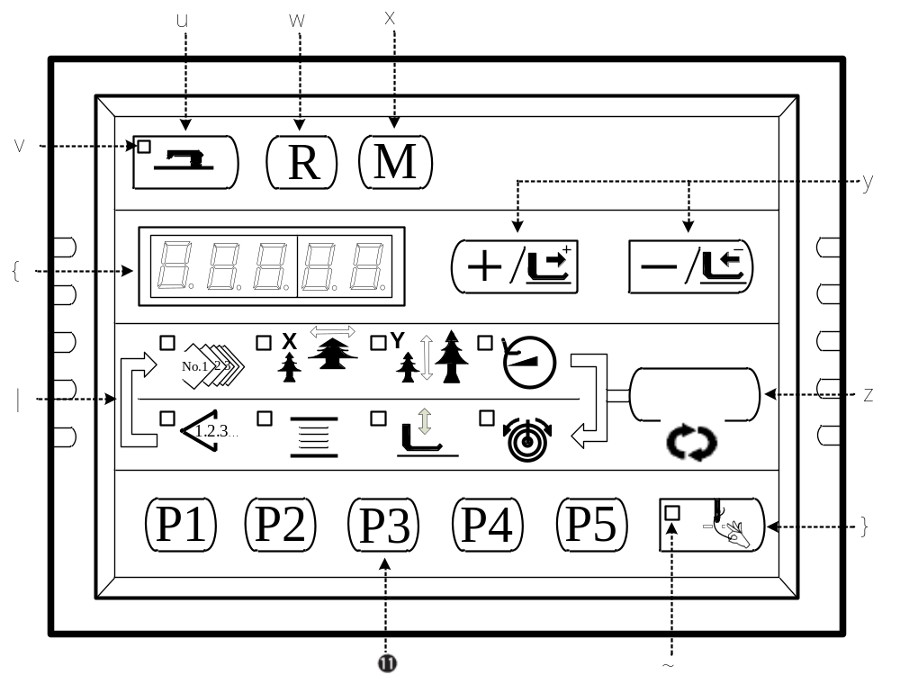
“Ready”key
This key changes over the setting state from the panel to the sewing state where the sewing machine actually operates.
“Sewing LED”
This LED goes off at the time of setting state and lights up at the time of sewing state. Change over can be performed with “Ready”key.
“Reset”key
This key is used for canceling error or returning the set value to the initial value.
“Mode”key
This key makes the setting mode of the memory switch.
“+/Feed forward”key and “-/Feed backward”key
This key is used for changing pattern NO. and X/Y scale, and feed forward / feed backward.
“Selection”key
This key selects the item to be set. Item selection LED of the selected item and the set value are displayed.
 Data indication LED
This LED indicates the set values of the selected items such as pattern NO., X/Y scale, etc.
 Item selection LED
LEDs of the selected items light up.
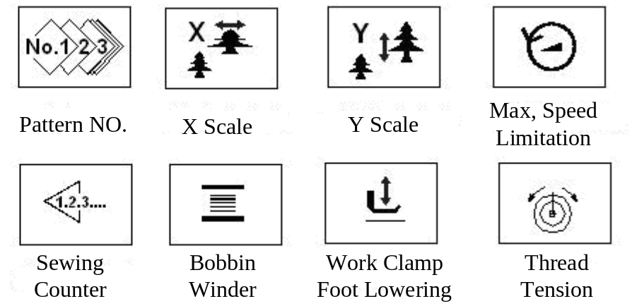
 Needle thread clamp ON/OFF key
This key selects effective / ineffective of needle thread clamp. When it is effective, needle thread clamp display LED lights up.
 Needle thread clamp display LED
When this LED lights up, needle thread clamp operates.
Needle thread clamp display LED
This key registers the pattern. When this key is pressed, the pattern registered here can sew immediately.

2.2 Installing the Main Motor
Assemble the main motor to the main shaft through the coupling.And you need 4 screws to fix the coupling to the main shaft and the main motor. Fix the coupling with No.1 Screwand make sure that it is vertical towards the Flat Section, and then screw No.2 screw. Fix the coupling to the main motor with No.3 screw , and make sure it is vertical to the flat section of the main motor. Then screw the No.4 screw  to finish the assembling task. The following diagram shows you the details:
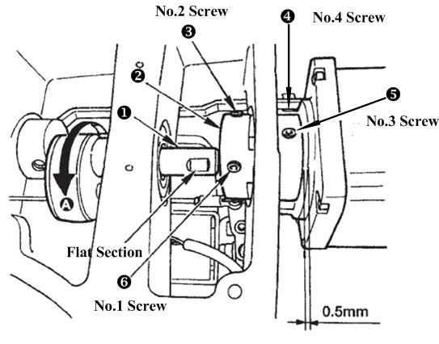
This following diagram shows you the position of the main motor (look from back, and the line is on your left-hand side):
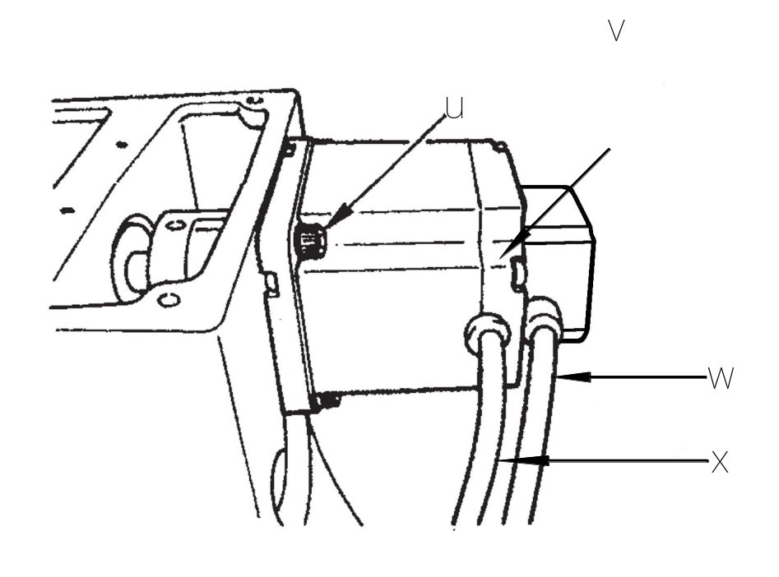
◆ Screws for fixing the main motor，totally 4； Screws for fixing the back of the motor，totally 4；  Sensor Cable； Power cord。

2.3 Test Mode
This mode is set to facilitate the electrical check for maintenance work.
1) Press  key, while the Sewing LED is not illuminated, and then the Panel display 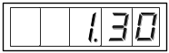. Press  simultaneously, you would hear the ring of the buzzer, and then you are able to enter the test mode.
Note: If you failed to press simultaneously, then you cannot enter the test mode.
2) Press  key to enter the test mode, and the screen displays “CP---”, as shown following:
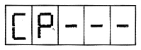
3) Press  key to start the Display Test. It automatically examine every 8-bit segment LED Display Module and the LED light illuminated or not, in a cycle process. The process is shown following:
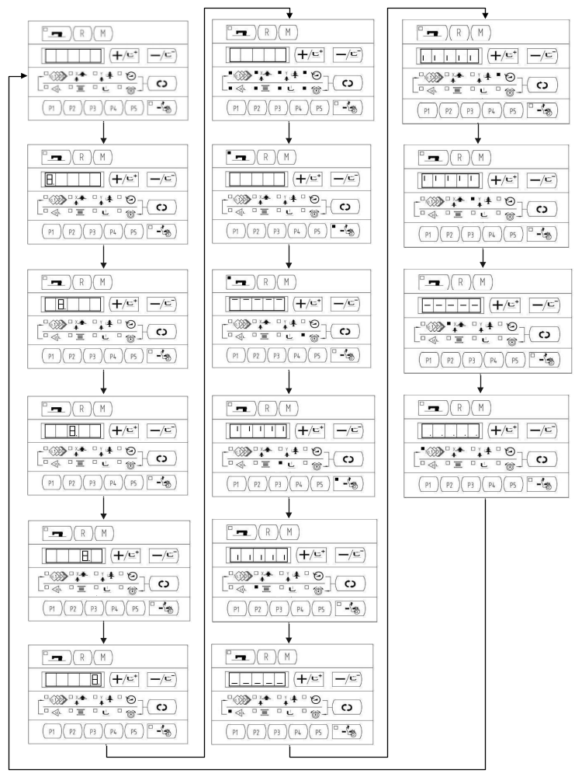
4) Press key again to end the Display Mode and the screen displays “CP-1”, as shown following:
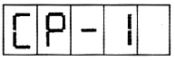
Note: You are not allowed to conduct other tests before the Display Mode Test.
5) Press 、 key to change the Indication NO. For details, please refer to the list below:

Indication No. | Item | Description
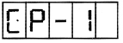 | Input signal check | State of the switch and the sensor will be indicated by 9 LEDs.
 | X/Y motor and Original Retrieval check | To indicate the X/Y motor step motion and original adjustment.
 | Continuous operation | Initial setting of the operation conditions will be performed, and the mode will move to the continuous aging mode.
 | Number of revolutions of main shaft check | Output of the specified number of revolutions will be made and the actual number of revolutions will be indicated.
 | _________________ | _________________
 | Presser and Trimming Original Retrieval check | Indicate the presser/trimming motor to move step by step; indicate original retrieval and the state of presser/trimming sensor.
 | Thread Clamp and Original check | Indicate the thread clamp motor to move step by step; indicate original retrieval and the state of thread clamp/origin sensor.
 | _________________ | _________________

6) Press  key to check the items.
7) Press to end up the test and return back to Step 5), however, if “CP-3” is selected, it is impossible to return to other test modes. Turn Off the power and turn On the power again in accordance with the starting way of the test mode.

2.3.1 CP-1 (Input Signal Check)
Status of input of switches and sensors is indicated o the 8 LEDs.
The table below is the list of LED indication, and you can understand to which LED each switch or each sensor is assigned. When “CP-1” is indicated on the screen, press key to enter into the mode and then number “1”is indicated.
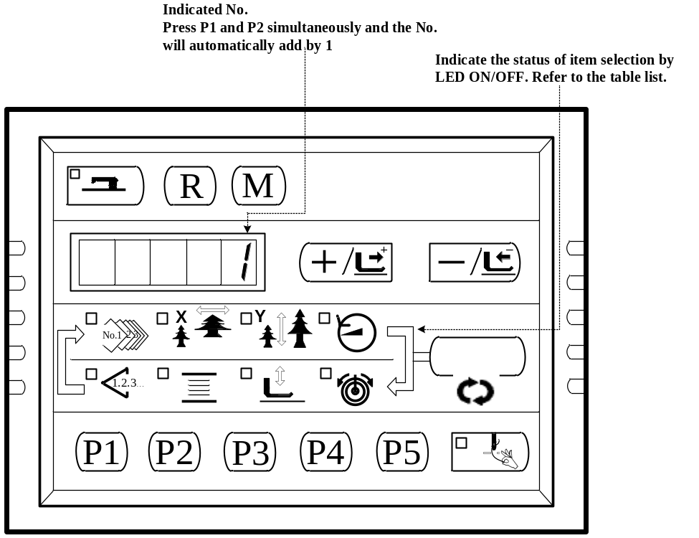

Indication of No.
Input No. | Pattern N0. LED | X Scale Rate LED | Y Scale Rate LED | Max. Speed LED | Sewing Counter LED | Bobbin Winder LED | Work Clamp foot lowering LED | Thread Tension LED
1 | / | / |  |  |  |  | 
2 | / | / |  |  |  |  |  | 
3 | / | / | / | / | / | / | / | /
4 | 0 step of pedal | 1 step of pedal | 2 step of pedal | / | / | / | / | /
5 | Presser solenoid sensor | Y origin sensor | X origin sensor | Thread Clamp origin sensor | Trimming sensor | Thread Clamp Sensor | / | /
6 | Main shaft angle indication
7 | Z phrase of Main motor | / | / | / | / | / | / | /
8 | / | / | / | / | / | Safety Switch | / | /

2.3.2 CP-2 (Origin Retrieval)
For origin adjustment, sensor adjustment of X/Y motor. The state of origin sensor and X/Y motor sensor will be indicated.
- Prepare
Press key to enter CP-2, “1” is displayed, and then press  to start origin retrieval. Meanwhile, the presser goes down, and the Sewing LED is illuminated.（The operation of pressing is not necessary, you could skip it to continue Step2 operation）
- Operation
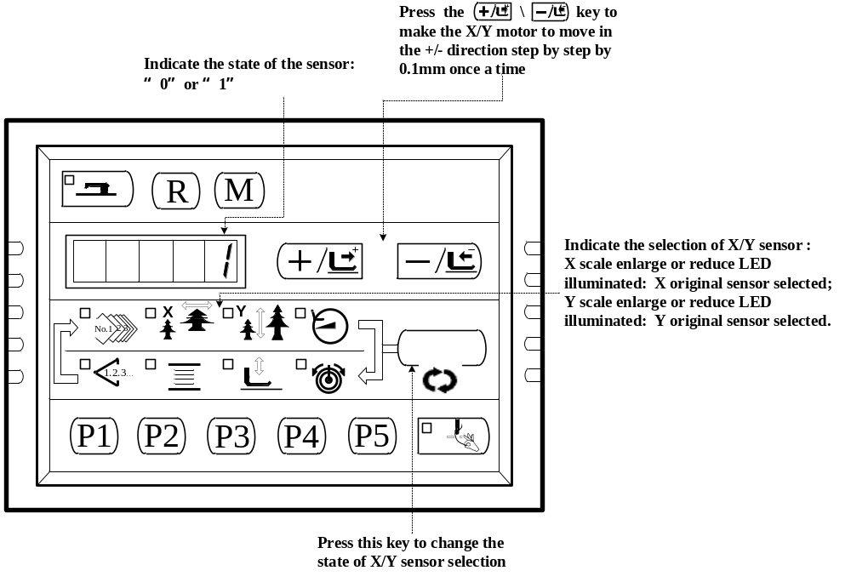

2.3.3 CP-3 (Continuous Operation)
When “CP-3”is indicated on the screen, press key to enter the continuous operation mode. Perform the initial setting of the operation conditions, and move to the continuous operation mode.
- Pause time setting
Press the 、 key to set the time of pause.
Setting range:1800 ms to 9999 ms (in a unit of 100 ms) (the default value is 2000ms)
Update the time of pause by pressing down the key, and the setting moves to the automatic origin retrieval setting.
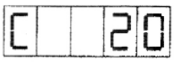
- Origin retrieval setting
Press the 、 key to set.
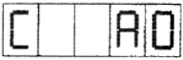
A0：Ineffective ；
A1：Every time .

Press the key to finish setting and move to Pattern No. setting.
- Continuous Operation
In the Ordinary Sewing Mode, you can change the Pattern No., X./Y scale Enlarge/Reduce setting, the Max speed and so on. The continuous operation can be stopped at the time of pause by depressing the key.

2.3.4 CP-4 (Revolution Movement)
Output of the specified number of revolution is made and the actual number of revolutions is indicated.
- Prepare
Press key to enter CP-4, and “S400” is displayed. Press the key for origin retrieval and the Sewing LED lights up.
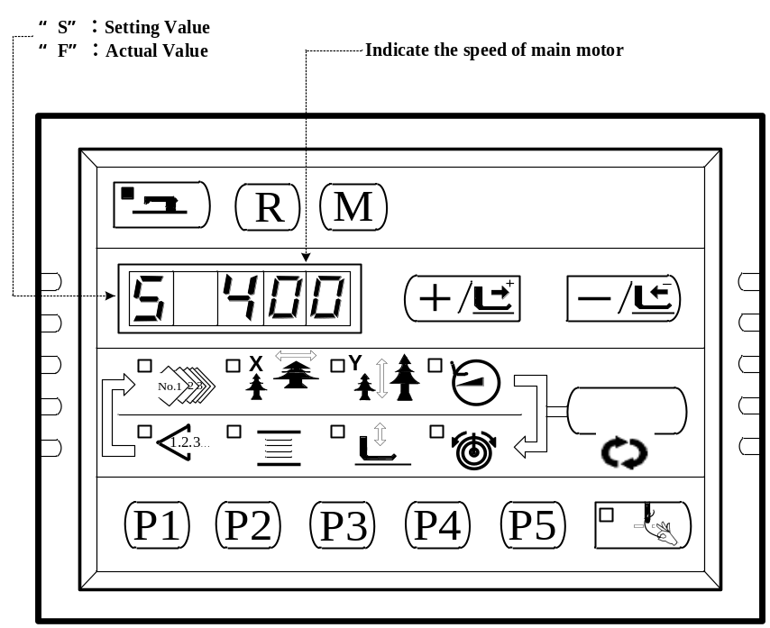
2) Operation 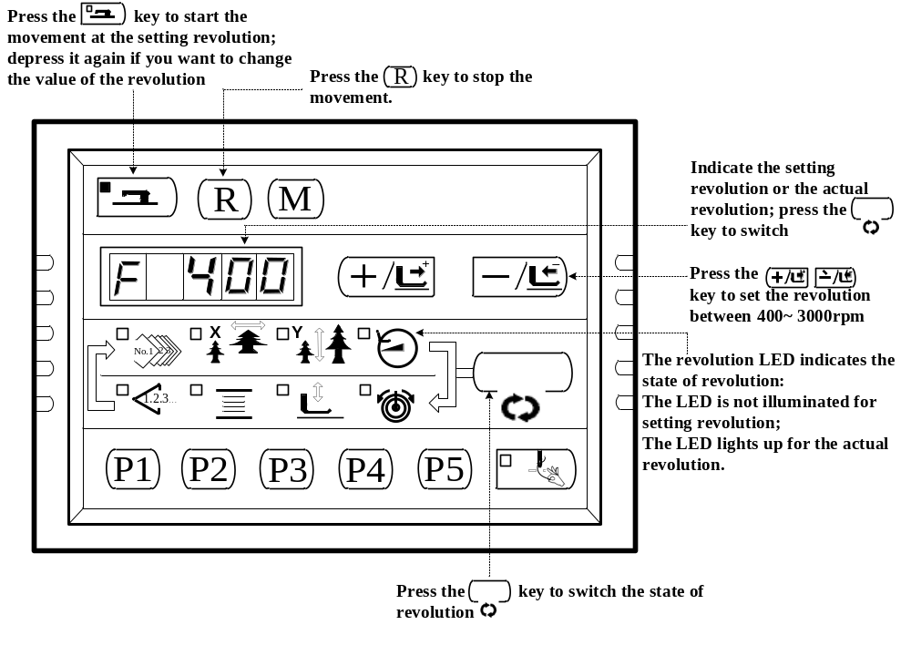

2.3.5 CP-6 (Presser and Trimming Motor / Origin Sensor Check)
Indicate the presser and trimming motor to move step by step, origin retrieval and the state of origin sensor and thread trimming sensor.
- Prepare
Press key to enter CP-4, and then press key for origin retrieval and the Sewing LED lights up.
2) Operation
Press  for 6 to 8 times, if the screen indication changes from “01” to “10”, the trimming sensor woks well; if not, please make proper adjustment.
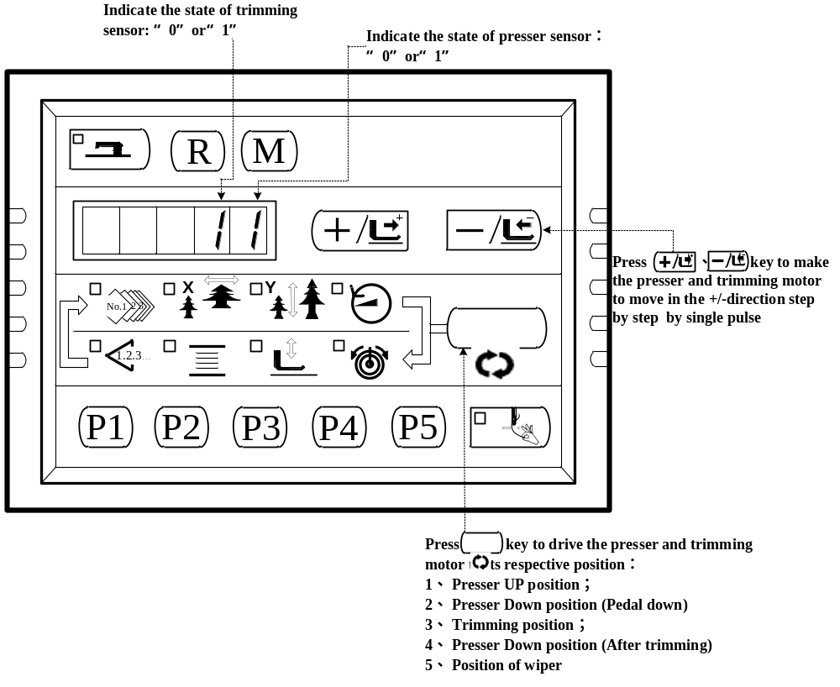
Press key to perform the functions above in a cycle. And press key to exit this mode.

2.3.6 CP-7 (Thread Clamp Motor / Origin Sensor Check)
Indicate the thread clamp motor to move step by step, origin retrieval and the state of origin sensor and thread clamp sensor.
- Prepare
Press key to enter CP-7, then press key for origin retrieval and the Sewing LED lights up. Press the pedal switch to perform the origin retrieval and “10” is indicated on the screen.
- Operation
Press 、key to make the thread clamp motor move step by step by single pulse. Press key to move the thread clamp backward; press key to move the thread clamp forward. 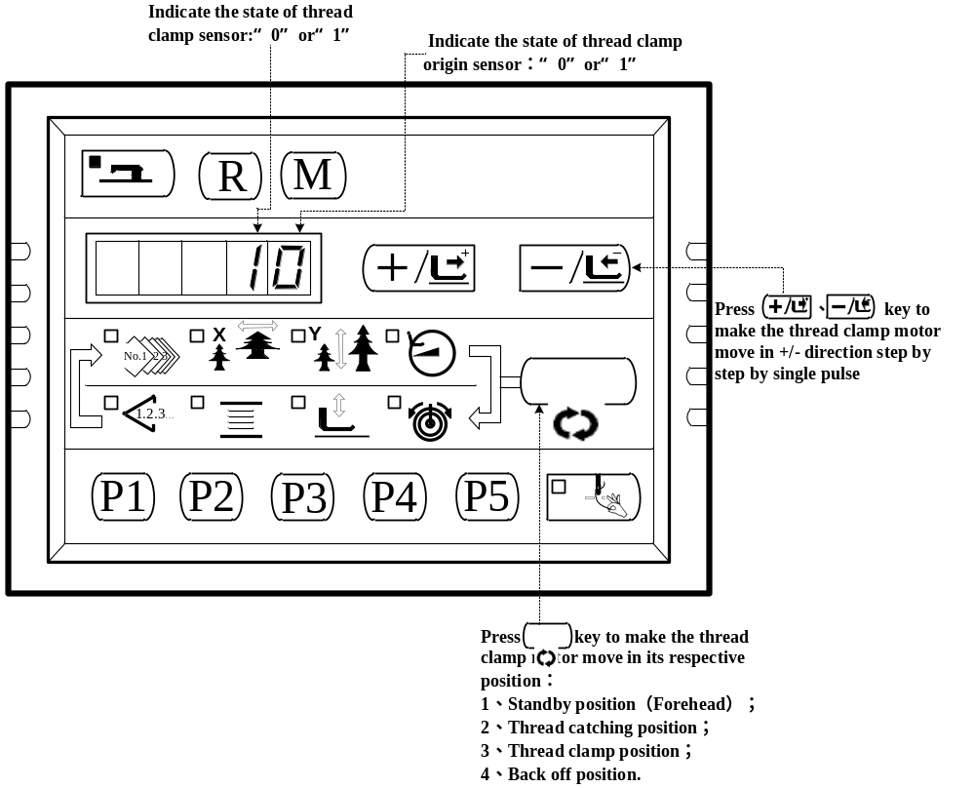
Press key to perform the functions above in a cycle. And press key to exit this mode.

2.4 Operation of the Sewing Machine (Basic)

2.4.1 Item Data Setting
Set each item following the procedure described below.
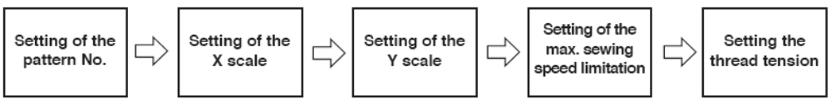
  - Turn ON the Power Switch
Pattern No. of the item selection light up, and the pattern No. is indicated on the data display.
  - Setting of the Pattern No.
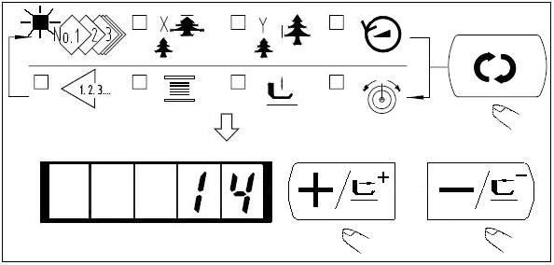
（1）Press thekey to indicate the item“Pattern No.” .
（2）Press theorkey to indicate “14”on the display.
（Pattern No. is set to 14.）
Caution：Refer the pattern No. to the separate table
  - Setting of the X Scale
(1) Press thekey to indicate the item “X scale” .
(2) Press theorto indicate “100”. (Set X scale to 100%)
Caution：
The setting exceeding 100% is dangerous since the needle and the cloth presser interferes with each other and needle breakage or the like will occur.

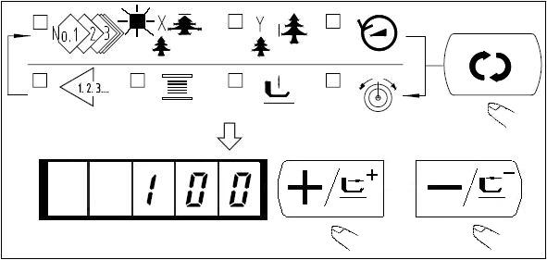

  - Setting of the Y Scale
(1) Press thekey to indicate the item “Y Scale” .
(2)Press the orkey to indicate “100”. (Set X scale to 100%.)
Caution：
The setting exceeding 100% is dangerous since the needle and the cloth presser interferes with each other and needle breakage or the like will occur.

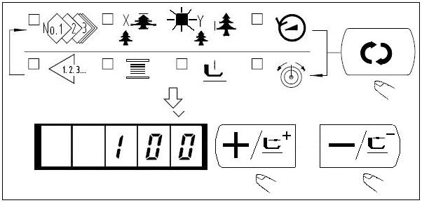

  - Setting of the Max. Sewing Speed Limitation
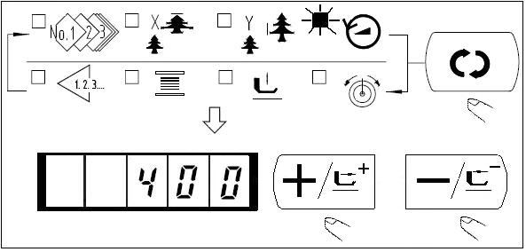
- Press thekey to indicate the item “Speed”.
- Press theorkey to indicate “400”（Setting of 400rpm）
- Press R key to set the system default value, the Max. speed.

  - Setting the Thread Tension
(1) Press thekey to indicate the “Thread Tension” .
(2) Press theorkey to indicate “50”（0 to 200 can be set.）
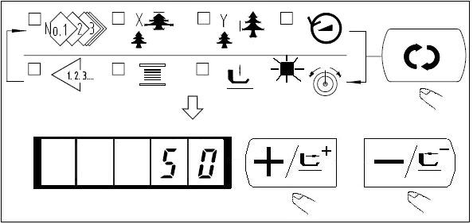
(1) Press thekey.
(2) After the work clamp feet have moved and gone up, the sewing LED lights up, and the sewing is ready.
Caution:
When the presser is raised, be careful that fingers are not caught in the presser since the presser moves after having lowered.
  - Finsh of Setting

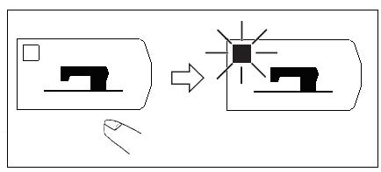
- When key is pressed, the set value of pattern No.,
X/Y scale, etc, are memorized.
- If key is pressed, you can make sure of the respective setting items again. However, the items can not be changed in the state that the Sewing LED is lit up.
- When key is pressed, the Ready LED goes off. Set values of the respective items can be changed.
- Use the machine after confirming the pattern No. When key is pressed while the pattern No. is indicated ”0”(state at the time of delivery), error display E-10 appears. At this time, re-set the Pattern No.
- When turning OFF the power without pressing key, the set values of pattern NO., X/Y scale, number of max. rotation, and thread tension are not memorized.

2.4.2 Checking the Contour of a Sewing Pattern
 Warning:
Make sure without fail of the contour of the sewing pattern after selection of the sewing pattern. If the sewing pattern extends outside the work clamp feet, the needle with interfere with the work clamp feet during sewing, causing dangerous troubles including needle breakage.
(1) Press thekey to make the Ready LED light up.
(2) Select the work clamp foot lowering with key. Lower the work clamp foot with the foot switch.
Note: The sewing machine does not start even when the foot switch is depressed under this mode.
(3) Presskey in the state that the work clamp foot is lowered.
Note: The work clamp foot does not go up even when the foot switch is detached.
(4) Confirm the contour of the pattern with orkey.
(5) The work clamp foot will go up when is pressed.
(6) Use key to move to other items, then press key to finish, and the sewing LED goes off.

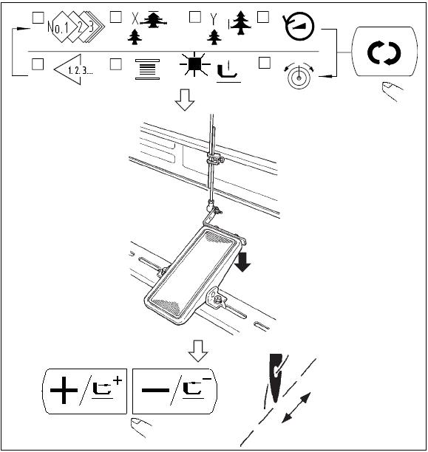

2.4.3 Sewing
- Set a workpiece on the work clamp foot section.
- Depress the pedal switch to the first step, and the work clamp feet will come down. If you detach your foot form the pedal switch, the work clamp feet will go up.
- Depress the pedal switch to the second step after descending the work clamp feet at the first step, and the sewing machine will start sewing.
- After the sewing machine completes sewing, the work clamp feet will go up, and return to the sewing start position.
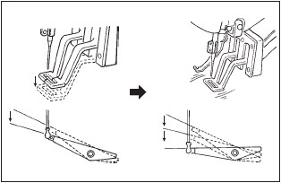

2.4.4 Change to Other Sewing Pattern
(1) Make sure the Sewing LED go off withkey.
(2) Presskey and select the item of pattern No. 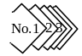.
(3) Set the pattern No. withkey orkey.
(4) Similarly, setting of X/Y scale, speed, etc. is performed.
(5) When key is pressed, the Sewing LED light up and the sewing machine is in the sewing ready state.
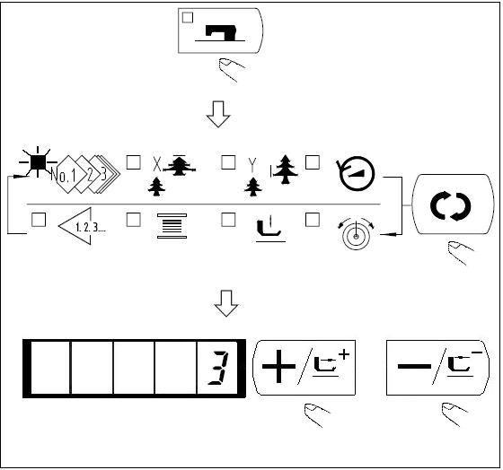

2.4.5 Winding a Bobbin
(1) Presskey to make the Sewing LED go off.
(2) Select the bobbin winder withkey.
(3) Presskey. The work clamp feet come down and the Sewing LED lights up.
(4) When the pedal is depressed, the sewing machine rotates.
(5) When the pedal is depressed again, orkey orkey is pressed, the sewing machine stops.
(6) Whenkey is pressed, the Sewing LED goes off, the work clamp feet go up and key become effective.
Caution: Bobbin winder does not work immediately after Turning ON the power. Perform the bobbin winding after setting pattern NO. or the like once, pressing the key, and making the Sewing LED light up.

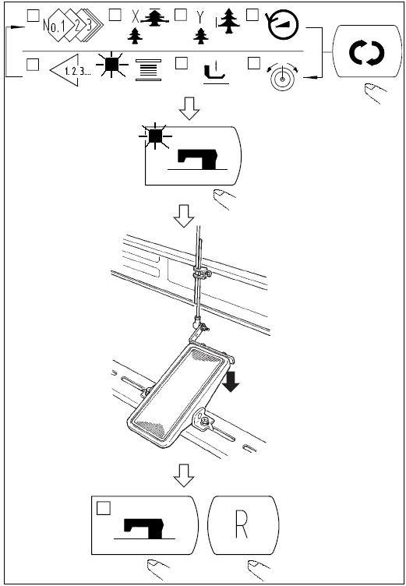

2.4.6 Thread Clamp Device
Trouble of sewing (slip-off of needle thread, stitch skippig, or stain of needle thread) at the time of high speed start can be prevented with the thread clamp device. The thread clamp device works in the state that the thread clamp indication LED lights up and does not work when the LED goes off. Changeover of ON/OFF motion is performed with  key. When the thread clamp device is OFF, the start automatically becomes the slow start.

Caution: When memeory switch No.35 is “1”(prohibited), the thread clamp does not work. In addition, key is ineffective.
*Masters that demand special attention when using the needle thread clamp device
(1) In case of with the needle thread clamp (motion), make shorter the length of needle thread remaining on the needle at the sewing start for use. When the length of needle thread is lengthened, needle thread on the wrong side of material is apt to protrude. In addition, when the length is excessively lengthened, the end of needle thread held by the needle thread clamp may be rolled in the seams.
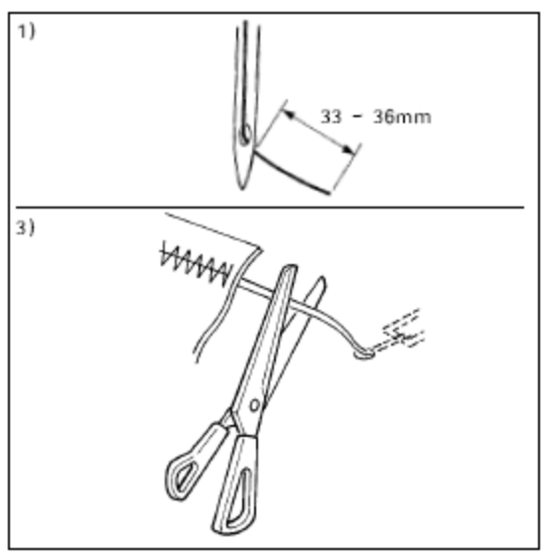
- In case of with the needle thread clamp, the standard of the length is 33 – 36mm.
- When needle threadlong after replacing thread or the like or sewing while holding needle thread by hand, Turn OFF the THREAD CLAMP key.
- When the needle thread held with the thread clamp is rolled in the seams, do not draw the material forcibly and cut the connecting needle thread with the scissors or the like. The seams are not damaged since it is the needle thread at the sewing start.

（2）It is possible to adjust needle thread shorter by making the needle thread clamp work while holding the stabilized sewing at the start of sewing and the gathering (bird’s nest) of needle thread on the wrong side of material can be lessened. However, for the pattern which the stitch for neatly rolling in needle thread is short, needle thread may protrude from the wrong side of material. Select with/without thread clamp referring to the item below.
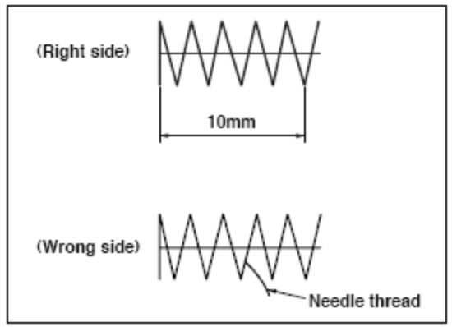
1. When the sewing length is short(less than approximately 10mm), the end of needle thread may protrude like beard even adjusting needle thread shorter.

(3) When the type of lower plate that material does not come in closely contact with throat plate is used, needle thread on the wrong side of material may be rolled in the seams regardless of needle thread play or sewing length.
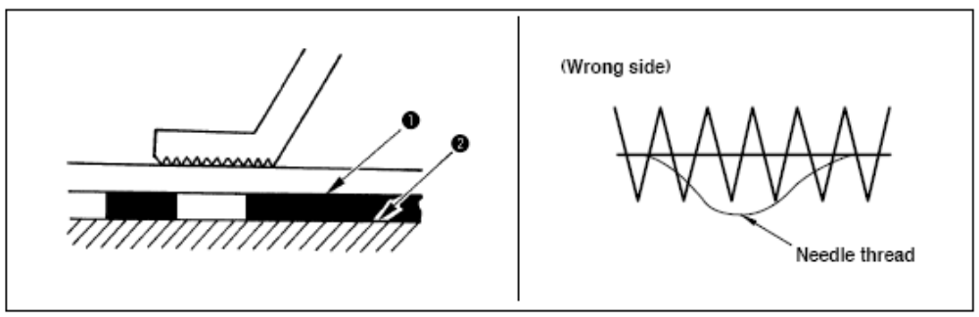
(4) When the thread clamp is used, and bobbin thread at the sewing start appears on the right side of material, reduce thread tension at the sewing start (2 to 3 stitches) and bobbin thread becomes less conspicuous.
[Example of setting ] Tension of 1 to 2 stitches at the sewing start is “20” when sewing tension setting is “35”.

2.4.7 Bobbin Thread Counter
(1) Presskey to indicate the Counter
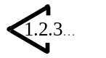.
(2) Then press thekey.
(3) Then press the orkey, and set the specified number of times that can be sewn with a bobbin.
(4) Every time, the sewing machine finishes a sewing cycle, counting-down is made by one.
(5) When the sewing machine finishes the specified number of times, the sewing machine doe not start even if depressing the pedal.
(6) Replace the bobbin with a new one, and press the key. The value of the counter returns to the set value.
(7) Repeat the steps of procedure from the steps (3) to (5).
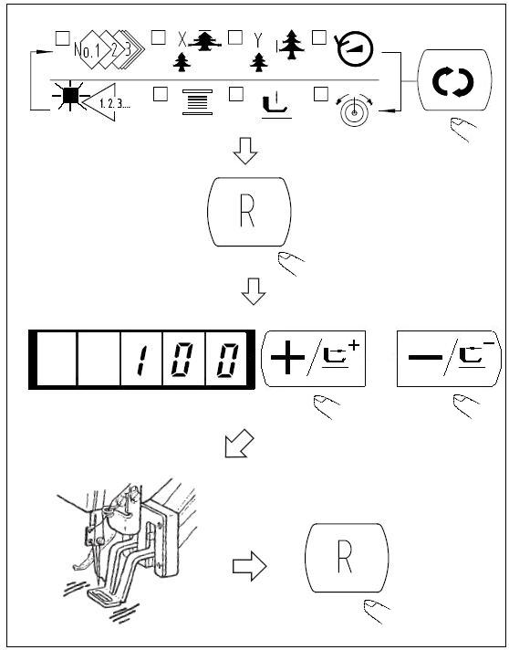

2.4.8 Temporary Stop
When memory switch No.31 is set to “1”, key can be used as the temporary stop key.
- Sewing machine stops by means of key. 
Error 50 is indicated.
- There are two operations after stop as below.
◆ Presskey to perform thread trimming, perform position withorkey, and re-start by means of the start switch.
❖ Presskey to perform thread trimming, and press againkey to return to the origin.

2.4.9 Setting the Pattern Thread Tension
Needle thread tension for 6 stitches at the sewing start, the portion which is changed over from basting stitch to zigzag stitch, and the portion of the stitch at the sewing end can be individually set.
- When the sewing LED lights up, presskey to indicate the needle thread tension.
- Lower the presser with foot pedal. (Caution: When the foot pedal is depressed until it will go no further, the sewing machine starts. So, be careful.）
- Move the feed with or key.
- “c” is indicated at the position where the tension position is possible.
- Pressingkey, set the tension with orkey.
- Repeat steps 3), 4) and 5) to set the tension.
- When setting is complete, presskey. The presser moves to the origin and goes up.
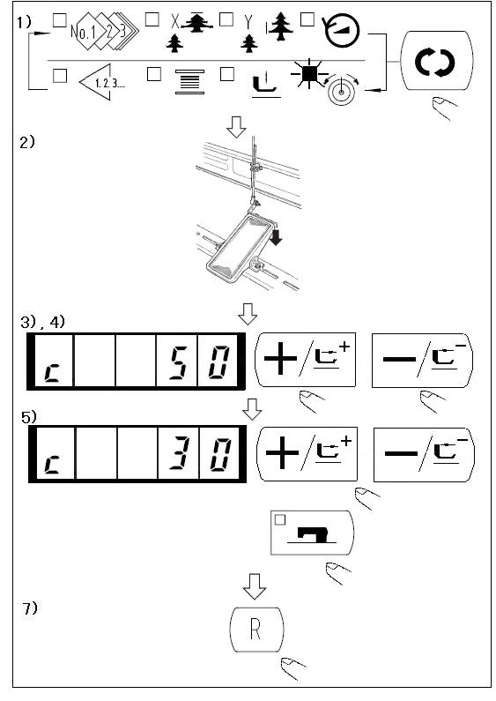

2.4.10 Table of the Standard Patterns
NO. | Stitch Diagram | Numbers of Stitches | L×W（mm） |  | NO. | Stitch Diagram | Numbers  of Stitches | L×W（mm）
1 |  | 42 | 16×2 |  | 2 |  | 42 | 10×2
3 |  | 42 | 16×2.5 |  | 4 |  | 42 | 24×3
5 |  | 28 | 10×2 |  | 6 |  | 28 | 16×2.5
7 |  | 36 | 10×2 |  | 8 |  | 36 | 16×2.5
9 |  | 56 | 24×3 |  | 10 |  | 64 | 24×3
11 |  | 21 | 6×2.5 |  | 12 |  | 28 | 6×2.5
13 |  | 36 | 6×2.5 |  | 14 |  | 15 | 8×2
15 |  | 21 | 8×2.2 |  | 16 |  | 28 | 8×2
17 |  | 21 | 10×1 |  | 18 |  | 28 | 10×1
19 |  | 28 | 25×1 |  | 20 |  | 36 | 25×1
21 |  | 41 | 25×1 |  | 22 |  | 44 | 35×1
23 | 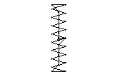 | 28 | 4×20 |  | 24 | 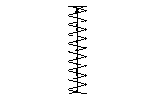 | 36 | 4×20
25 | 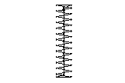 | 42 | 4×20 |  | 26 | 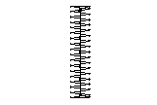 | 56 | 4×20
27 |  | 18 | 1×20 |  | 28 |  | 21 | 1×10
29 |  | 21 | 1×20 |  | 30 | 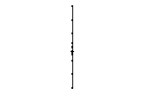 | 28 | 1×20
31 |  | 52 | 10×7 |  | 32 |  | 63 | 12×7
33 |  | 24 | 10×6 |  | 34 |  | 31 | 12×6
35 |  | 48 | 7×10 |  | 36 |  | 48 | 7×10
37 |  | 90 | 24×3 |  | 38 |  | 28 | 8×2
39 |  | 28 | 12×12 |  | 40 |  | 48 | 12×12
41 | 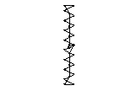 | 29 | 2.5×20 |  | 42 | 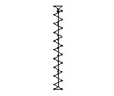 | 39 | 2.5×25
43 | 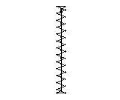 | 45 | 2.5×25 |  | 44 |  | 58 | 2.5×4.4
45 |  | 76 | 2.5×4.4 |  | 46 |  | 42 | 2.5×4.4
47 |  | 91 | 8×8 |  | 48 |  | 99 | 8×8
49 |  | 148 | 8×8 |  | 50 |  | 164 | 8×8
51 |  | 49 | 17×10 |  | 52 | 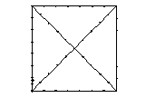 | 67 | 20×20
53 |  | 21 | 8×8 |  | 54 | 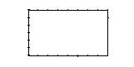 | 32 | 26×15
55 | 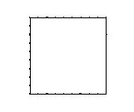 | 41 | 25×25 |  | 56 | 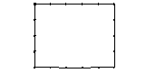 | 39 | 19×15
57 |  | 47 | 24×15 |  | 58 | 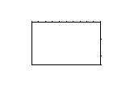 | 63 | 32×20
59 |  | 124 | 10×10 |  | 60 |  | 85 | 10×12

2.5 Operations of P Pattern and C Pattern

2.5.1 Perform Sewing Using the Pattern Key（）
Patterns (No.1 to 200) which have been already registered can be registered to P1 to P50. It is possible to change and register the scale, max speed limitation, thread tension and sewing position. Same as the patterns (No.1 to 200), P1 to P50 are used by the selection by scrolling the pattern Nos. The pattern calling from P1 to P25 can be made by one-touch as well.

When selecting P6 to P25, perform the selection by combination (simultaneously pressing) of keys as shown in the table below.

P-No. | Selection Key | P-No. | Selection Key | P-No. | Selection Key | P-No. | Selection Key
P1 | P1 | P8 | P1+P4 | P15 | P4 +P5 | P22 | P2+P3+P4
P2 | P2 | P9 | P1+P5 | P16 | P1+P2+P3 | P23 | P2+P3+P5
P3 | P3 | P10 | P2+P3 | P17 | P1+P2+P4 | P24 | P2+P4+P5
P4 | P4 | P11 | P2+P4 | P18 | P1+P2+P5 | P25 | P3+P4+P5
P5 | P5 | P12 | P2+P5 | P19 | P1+P3+P4
P6 | P1+P2 | P13 | P3+P4 | P20 | P1+P3+P5
P7 | P1+P3 | P14 | P3+P5 | P21 | P1+P4+P5
1. Register of the Pattern Key
Setting example: Register following setting to the P2, Pattern No.3, X scale rate: 50%, Y scale rate: 80%, Max. speed limitation: 2000 rpm, Pattern position: 0.5 mm to the right and 1 mm to the front.
1) Turn ON the power switch and press  key to enter mode setting (memory switch setting). (Sewing LED should be put out.) 
2) Indicate the pattern register mode
with orkey.
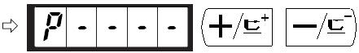
3) Press key.
Enter the pattern register mode. 
4) Press 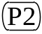 key. (Select P-No. to be registered.)
Selection can be performed with orkey. 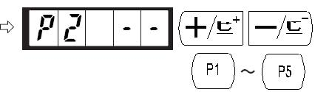
5) Press key to indicate the Pattern No. .
Set the Pattern No. to “3” with orkey. 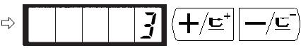
6) Press and set as follows with orkey.
X Scale rate: 50%, 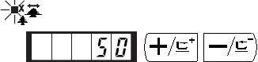
Y Scale rate: 80%, 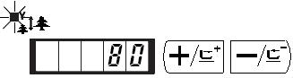
Max speed limitation :
“2000” rpm
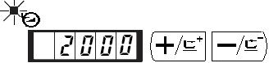
Thread Tension “50” 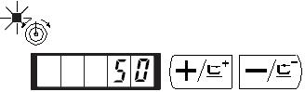
7）Press key and “X Scale rate”
indication becomes 0.0.
Traveling amount in X direction can be
set in 0.1mm unit. Set 0.5 with orkey.
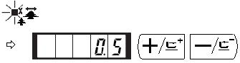
8) Press key and “Y Scale rate”
indication becomes 0.0.

Traveling amount in Y direction can be
set in 0.1mm unit. Set -1.0 with orkey.
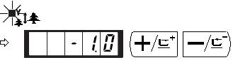
9) Press key to finalize the setting.
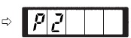
10) Press key.
Pattern register mode is finalized. 
11) Press key.
Mode setting is finalized and the mode returns to the normal mode.

2. Sewing
Operation Example: After perform sewing of the contents of the register P2, perform sewing with the contents of P3.
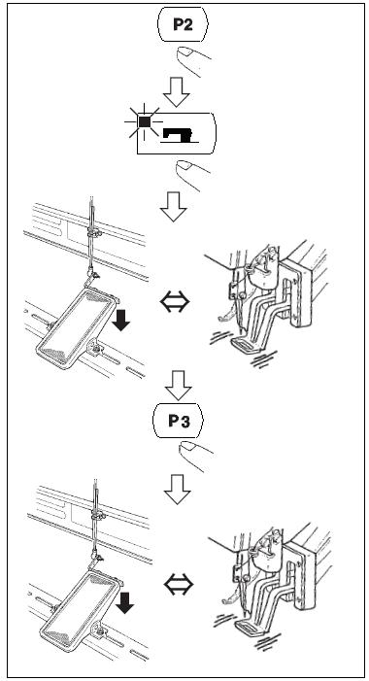
(1) Turn ON the power switch.
(2) Press the key.
(3) Pres the key, and when the sewing LED lights up, the work clamp foot goes up after it has moved.
(4) Check the contour of the sewing pattern.
(Refer to the item “Checking the Contour of a Sewing Pattern”).
(5) If the contour of the sewing pattern is acceptable, the sewing can be made.
(6) Press key after completion of sewing and the presser comes down. The presser moves to the sewing start point after origin retrieval and goes up.
(7) Perform the above item (4) and (5).

2.5.2 Perform Sewing Using the Combination Function
By arranging in order to use the pattern register (P1 to P50) which have been already registered and registering in C1 to C20, the sewing pattern will change in the order every time the sewing machine finishes the sewing. Every one combination No. can be registered up to the maximum 30 patterns.
    - Register of the Combination
Setting example: Combine in the order of P1, P2 and P3, and register them in the C1.
1) Turn ON the power switch and press key
to enter the mode setting (memory switch setting).
(Sewing LED should be put out.)

2) Indicate the combination mode with orkey. 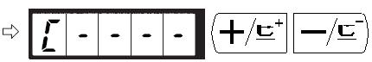

- Press key. Sewing LED lights up to enter the
combination mode. C1 to C20 can be selected with
orkey. 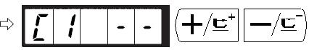
- Press key, and then press key.
is set to the first pattern of C1. P1
to P50 can be selected with or
key as well.
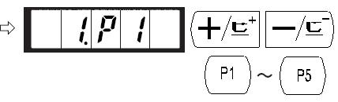
- Press key, and then press key.
P2 is set to the second pattern of C1. P1
to P50 can be selected with or
key as well.
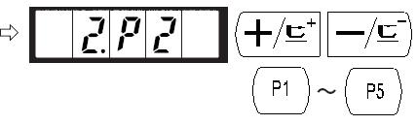
- Press key, and then press key.
P3 is set to the third pattern of C1. P1 to P50
can be selected with orkey as well.
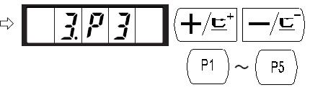
- Press key to finalize the register.

- Press key. Combination register mode is finalized.

- Press key.
Mode setting is finalized and the mode returns
to the normal mode.

    - Sewing Operation
Operation example: Perform sewing with the contents of the registered C1.

(1) Turn ON the power switch.
(2) Set the pattern No. to “C1”using the or key.
(3) Press thekey. When the sewing LED lights up, the work clamp feet will go up after having moved.
(4) If the contour of the pattern is acceptable, the sewing can be made.
(5) Every time the sewing is finished, the step is made in the order of the combination. After completing one cycle of sewing., the step returns to the first step.
- When you desire to return the pattern to the previous one or skip the next pattern after sewing, press orkey in a state that the sewing LED lights up.
- If the contents of P1 to P50 are changed after registration of C1 to C20, the contents of P1 to P50 used in C1 to C20 will change. So, be careful.
- Make sure of the contour of the pattern for each or the patterns. (Refer to the item “Checking the contour of the sewing pattern”.)
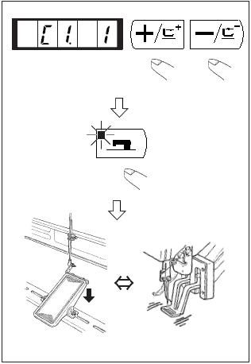

2.6 How to Use the Memory Switch (User Class)
The sewing machine operation can be changed by changing the setting of the memory switch.

2.6.1 Start and Change of the Memory Switch
1) When key is pressed in the state that the sewing LED is put out, the memory switch setting mode is obtained.
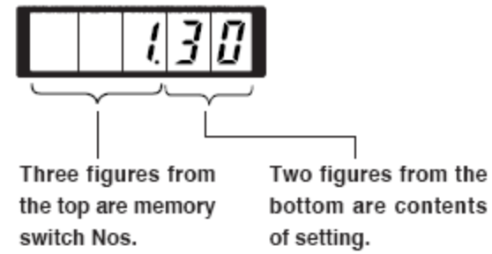
1.30 which is indicated when “M”
key is pressed indicates that the max. speed limitation of the first memory switch is 3,000 rpm. (State at the time of delivery from factory)

2) Change the memory switch No. with
orkey. 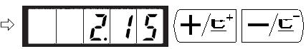

3) Adjust the memory switch No. to the No.
you desire to change, and press key,
the sewing LED lights up.
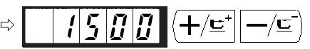
4) Change the content of the memory switch
with orkey.
5) The value can be returned to the value at the time of delivery from the factory with key.
6) Press key to register the contents of change. Sewing LED goes off and the mode returns to the selective state of the memory switch No.
7) Press key to finalize the memory switch setting mode and the mode returns to the normal mode.

2.6.2 Example of the Memory Switch Setting
1. Setting the Max. speed Limitation
Setting example: Setting the max. speed limitation to 1,800 rpm.
1) Press key in the state that the sewing LED is put out.
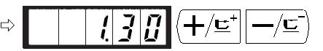
The memory switch is started and the contents of memory switch No.1 are indicated.
It is not necessary to change the sewing speed since the max. speed limitation of the sewing machine is set with memory switch No.1. The indicated memory switch No. can be changed over with orkey.
2) Presskey in the state that memory switch
NO.1 is indicated to make the sewing LED
light up. The contents of memory switch No.1
(max. speed limitation value of the sewing
machine ) are indicated.
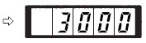
3) Set “1800” with orkey. 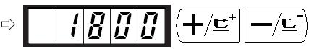
4) Register the value with key. Sewing LED goes off.
5) Press key to return to the normal state.
2. Setting the Soft Start Speed at the Sewing Start
The speed of the first stitch to the fifth stitch at the sewing start can be set in a unit of 100 rpm. Two kinds of settings, in case of with needle thread clamp and without needle thread clamp can be performed. (See Table of Functions of the Memory Switch.)

In case of needle thread clamp unit: rpm
 | State when delivered（rpm） | Setting range
1st Stitch | 1500 | 400～1500
2nd Stitch | 3000 | 400～3000
3rd Stitch | 3000 | 400～3000
4th Stitch | 3000 | 400～3000
5th Stitch | 3000 | 400～3000
Setting Example: In case of with needle thread clamp, the speed is changed as follows.
1st stitch form 1,500 to 1,000 rpm and 2nd stitch form 3,000 to 2,000 rpm.
- Press in the state that the sewing LED is put out.
- Indicate memory switch No.2 with
orkey. Here, set the sewing speed of
the first stitch.
- Press key. The sewing LED lights up and
the set value of the first stitch is indicated.

- Indicate “1000” with orkey. The
value returns to the initial value at the time of
delivery from the factory with key.
Press key to cancel the operation here and
return to the state of step 2).
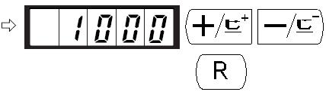
- Press key. The sewing LED goes off and
the set value of the first stitch is registered.

- Indicate memory switch No.3 with or
key. Here, set the sewing speed of second stitch.
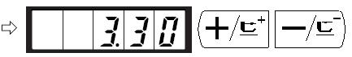
- Press key. The sewing LED lights up and the set
value of the second stitch is indicated.

- Indicate “2000” with orkey. The value
returns to the initial value at the time of delivery from
the factory with . Press key to cancel the
operation here and return to the state of step 6).
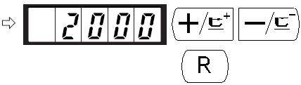
- Press key. The sewing LED goes off and the set
set value of the second stitch is registered.

- Press key. The memory switch setting mode is finalized and the mode returns to the normal mode.
3. Setting Whether the Calling of Pattern Data is Operative or Not
By making inoperative the calling of the unnecessary pattern, this setting prevents the different pattern from calling by mistake.
Also, it is possible to call and use the necessary pattern.
Setting Example: Make the calling of pattern Nos.2 and 3 inoperative.
- Press key in the state that the sewing LED
is put out.
- Indicate memory switch No.201 with orkey.
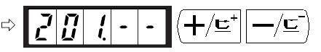
- Press key. The sewing LED lights up and
the set value of pattern No.1 is indicated.
Set value 1: Calling is operative. 
Set value0: Calling is inoperative.
- Set pattern No.2 with orkey
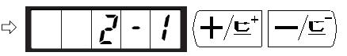
- Set the set value to “0” with key. 
- Set the pattern No.3 with orkey. 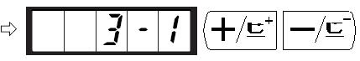
- Set the set value to “0” with key. 

- Press key to register the set value. The 
9) Press key. The memory switch setting mode is finalized and the mode returns to the normal mode.
4. Setting the Counter Operation
Setting Example: The production counter (adding method) can be changed to the bobbin thread counter (subtracting method).
- Press key in the state that the sewing LED
is put out.
- Indicate the memory switch No.18 with or
key. 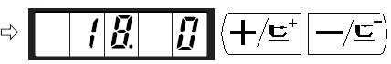
- Press key. The sewing LED lights up and
the set value of counter motion is indicated.

- Set the set value to “1” with key.
Set value 0: Production counter
Set value 1: Bobbin thread counter
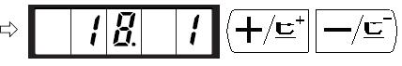
- Press key to register the set value. The sewing LED goes off.
- Press key. The memory switch setting mode is finalized and the mode returns to
the normal mode.

2.6.3 Table of Functions of the User Class Memory Switch
Indication |  |  |  |  |  | Function | Setting Rang | State When Delivered | Remarks
 |  | 1． | 3 | 0 |  | Max. sewing speed  （speed can be set in a unit of 100 rpm） | 400～3000 | 3000
 |  | 2． | 1 | 5 |  | Sewing speed of 1st stitch  (With needle thread clamp)  （speed can be set in a unit of 100 rpm） | 400～1500 | 1500
 |  | 3． | 3 | 0 |  | Sewing speed of 2nd stitch  (With needle thread clamp)  （speed can be set in a unit of 100 rpm） | 400～3000 | 3000
 |  | 4． | 3 | 0 |  | Sewing speed of 3rd stitch  (With needle thread clamp)  （speed can be set in a unit of 100 rpm） | 400～3000 | 3000
 |  | 5． | 3 | 0 |  | Sewing speed of4st stitch  (With needle thread clamp)  （speed can be set in a unit of 100 rpm） | 400～3000 | 3000
 |  | 6． | 3 | 0 |  | Sewing speed of 5th stitch  (With needle thread clamp)  （speed can be set in a unit of 100 rpm） | 400～3000 | 3000
 |  | 7． | - | - |  | Thread tension of 1st stitch (With needle thread clamp) | 0～200 | 200
 |  | 8． | - | - |  | Thread tension at the time of thread trimming | 0～200 | 0
 |  | 9． | - | - |  | Changeover timing of thread tension at the time of thread trimming | －6～4 | 0
 | 1 | 0． |  | 4 |  | Sewing speed of 1st stitch (Without needle thread clamp) (Speed can be set in a unit of 100 rpm) | 400～1500 | 400
 | 1 | 1． |  | 9 |  | Sewing speed of 2nd stitch (Without needle thread clamp) (Speed can be set in a unit of 100 rpm) | 400～3000 | 900
 | 1 | 2． | 3 | 0 |  | Sewing speed of 3rd stitch (Without needle thread clamp) (Speed can be set in a unit of 100 rpm) | 400～3000 | 3000
 | 1 | 3． | 3 | 0 |  | Sewing speed of 4th stitch (Without needle thread clamp) (Speed can be set in a unit of 100 rpm) | 400～3000 | 3000
 | 1 | 4． | 3 | 0 |  | Sewing speed of 5th stitch (Without needle thread clamp) (Speed can be set in a unit of 100 rpm) | 400～3000 | 3000
 | 1 | 5． | - | - |  | Thread tension of 1st stitch (Without needle thread clamp) | 0～200 | 0
 | 1 | 6． | - | - |  | Changeover timing of thread tension at the sewing start (Without needle thread clmap) | －5～2 | 0
 | 1 | 7． |  | 0 |  | X/Y scale enlargement, Max.speed whether could be changed | 0: Yes  1: No | 0
 | 1 | 8． |  | 1 |  | Counter Operation | 0: Production Counter（adding）  1：Bobbing thread counter  （subtracting） | 0
 | 3 | 1． |  | 0 |  | Sewing machine operation can be stopped with panel key (clear key) | 0：Ineffective  1：Panel reset key | 0
 | 3 | 2． |  | 1 |  | Buzzer Sound | 0：Without buzzer sound  1：Panel  operation sound | 1
 | 3 | 3． |  | 2 |  | Number of stitches that needle thread clamp releases is set. | 1～7 stithces | 2
 | 3 | 4． | - | - |  | Clamping timing of needle thread clamp can be delayed. | －10～0 | 0 | Timing is delayed in”-” direction
 | 3 | 5． |  | 0 |  | Needle thread clamp control can be prohibited. | 0：Normal  1：Prohibited | 0
 | 3 | 6． | - | - |  | Feed timing is selected. | －8～16 | 12 | Setting on excessive “-” side may cause needle breakage. Be careful when sewing heavy-weight material.
 | 3 | 9． |  |  | 0 | Execution of origin retrieval every time after completion of sewing | 0：Without  origin retrieval  1：With origin  retrieval | 0
 | 4 | 0． |  |  | 0 | Setting of origin retrieval in cycle  stitching | 0：Without origin retrieval  1：Every time 1  pattern is complete | 0
 | 4 | 2． |  |  | 0 | Needle bar stop position is set | 0：Up position  1：Upper dead  point | 0 | Needle bar rotates in the reverse direction after the UP position stop and stops when upper dead point stop is set
 | 4 | 6． |  |  | 0 | Thread trimming can be prohibited. | 0：Normal  1：Prohibited | 0
 | 4 | 9． | 1 |  | 6 | Bobbing winding speed | 800～2000 | 1600
2 | 0 | 1． | - |  | - | This function sets whether or not the calling of the pattern data is operative. | 0：Calling inoperative  1：Calling operative | Setting depends on the model used | Service pattern Nos. 1 to 64 can be individually set.
P | - | - | - |  | - | Register of the pattern is performed
C | - | - | - |  | - | Register of the cycle stitching is performed

3. Memory Switch (Service Class)
Service class memory switch is different from the user class and it is not allowed to be changed by users. We provide these functions to the professional for adjustment and maintenance.

3.1 Start and Change of the Memory Switch (Service Class)
When key is pressed in the state that the sewing LED is put out, the memory switch setting mode is obtained and is indicated. Then press simultaneously, and you will hear the buzzer ring. After that you have started the memory switch and you are allowed to change the settings.
The operation of service class memory switch is the same as that of user class memory switch. Refer to 【2.6 How to Use the Memory Switch (User Class)】for details.

3.2 Table of Functions of the Service Class Memory Switch
Indication | Function | Setting Range | State When Delivered | Remarks
21.-- | Position of Standard Pedal Step 1 | 50-500 | 140 | The stroke of depressing the pedal will be large if increase the value.
22.-- | Position of Standard Pedal Step 2 | 50-500 | 240 | The stroke of depressing the pedal will be large if increase the value.
23.-- | Starting Position of Standard Pedal | 50-500 | 370 | The stroke of depressing the pedal will be large if increase the value.
27.-- | Speed of Lowering  Presser | 100-4000pps | 4000
28.-- | Speed of Lifting Presser | 100-4000pps | 1500 | It will cause poor sewing if this value is set too high.
29.-- | Speed of Trimming·Presser after Sewing | 100-4000pps | 3000 | It will cause poor sewing if this value is set too high.
37. 0 | Presser Status after Sewing | 0：Lift Up  1：Depress Pedal to Lift Up the Presser | 0
38.0 | Presser don’t lift and depress pedal to sewing | 0：usual  1：Presser don’t lift | 0
43. 1 | Speed Choice When Trimming | 0：400rpm  1：800rpm | 1 | Speed of moving knife spreading the thread; the trimming is performed after the machine stops.
44. 1 | Feeding Cloth When Trimming at the Direction of Easy Trimming | 0：No  1：Yes | 1
45. 16 | Diameter of Thread Guider when Feeding at the time of Trimming | 16-40  （1.6mm-4.0mm） | 16  (1.6mm) | Amount of feeding will be more if the value is set larger
47. 0 | Prohibit Trimming | 0：Normal  1：Prohibited | 0 | Prohibit all trimming operation.
52.-- | Conduction Time of Wiper Solenoid | 10-500ms | 50 | Valid only wiper solenoid is chosen.
53.-- | Release Time of Wiper Solenoid | 10-500ms | 100 | Valid only wiper solenoid is chosen.
56.-- | +X Direction（R）Shifting Range | -20-20mm | 20 | Not consider the shape of Presser when delivered.
57.-- | -X Direction（L）Shifting Range | -20-20mm | -20 | Not consider the shape of Presser when delivered.
58.-- | +Y Direction（B）Shifting Range | -20-10mm | 10 | Not consider the shape of Presser when delivered.
59.-- | -Y Direction（F）Shifting Range | -20-10mm | -20 | Not consider the shape of Presser when delivered.
62. 0 | Perform READY when Power ON | 0：Normal  1：Perform READY when Power on | 0
67.-- | Main Control Software Version | 0或1 | 1 | Refer to 【3.3 Restore Default Setting】
68.-- | Stop Position Compensation | -10-+10 | 0
150.0 | Set the Safety Switch to be Invalid | 0：Normal  1：Invalid | 0
241.0 | Machine type | 0：reinforcement  7：Lockstitch Button | 0 | Refer to chapter 4.1
The functions above assumes for special repair or maintenance.

3.3 Restore Default Setting
When the users change the settings by accident, or the control system fails to work, you could try to restore the default setting.
Attention: Please be very careful when you decided to restore the setting, for the former setting will be replaced. If you get any question about this, please contact the technology support for help and conduct the default setting following his or her instruction.
Follow this steps to restore the default setting:
1) When key is pressed in the state that the sewing LED is put out, the memory switch setting mode is obtained and is indicated. Then press simultaneously, and you will hear the buzzer ring. After that you have started the memory switch and you are allowed to change the settings.
2) Press orkey to select function NO.67:
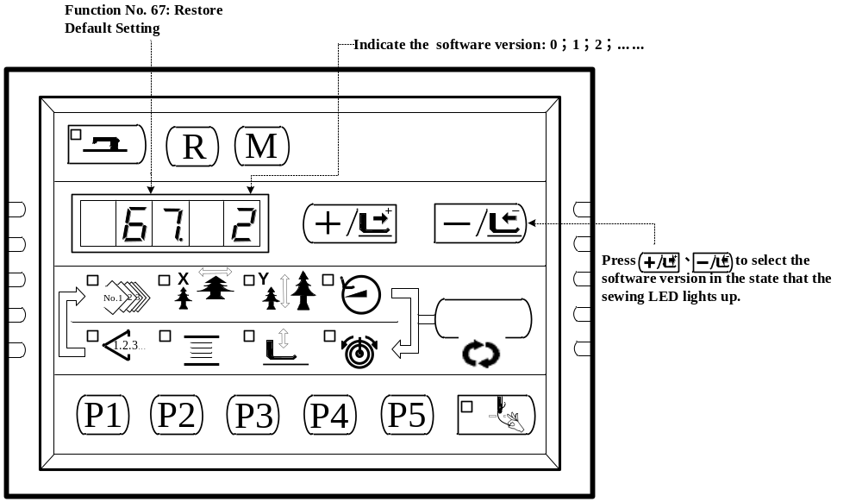
3）Press key to light up the sewing LED. Then press orkey to select the software version:

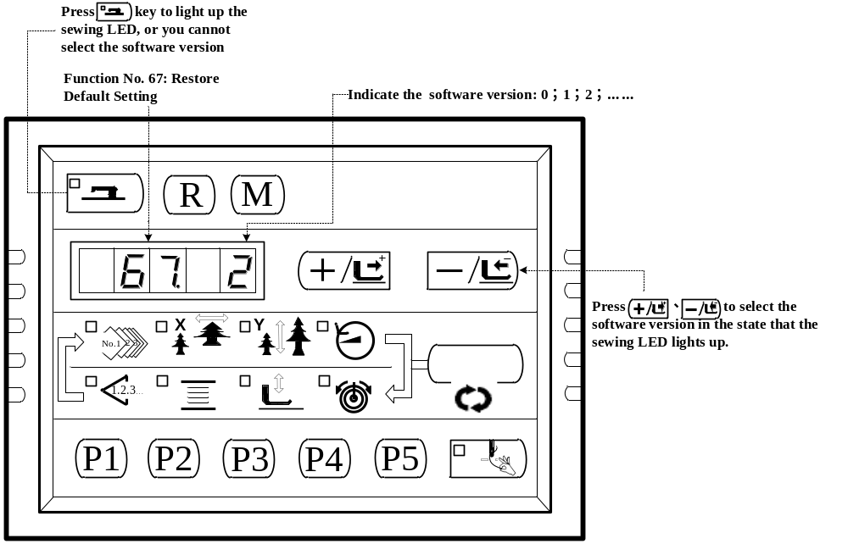
- For instance, the present software version is 2, then you can chose version 1 or 0 for restoring. The version you chose for restoring must be lower than the present software version.. Press key to confirm and the sewing LED goes off.
- Press key to exit and return to the normal state.
- Power off. 1 minute later, turn ON the power and wait for 20 seconds. The restoring process will automatically starts up. Then the screen lights up to indicate that the process is finished.
- After restoring, the present software version will automatically change to be the highest. For example, the default software version is 0 and 1, and after restoring, the present software version will be 2 in order to keep the default software version number.
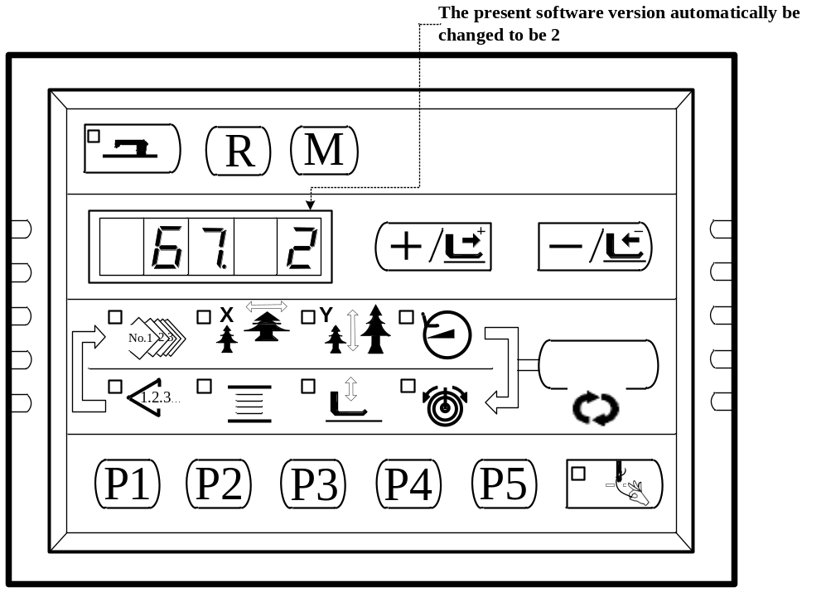
Note: During the restoring process (20 seconds after power on), if the power is cut by accident, the restoring process has to be aborted and you failed to restore the default setting. The software
will return to the former state before restoring.

4. Lockstitch Button Sewing Function

4.1 Lockstitch Button Sewing Function Setting
1、Press key, while the Sewing LED is not illuminated, and then the Panel display . Press simultaneously, you would hear the ring of the buzzer, and then you are able to adjust the setting.
2、Press 、key to select No.241：
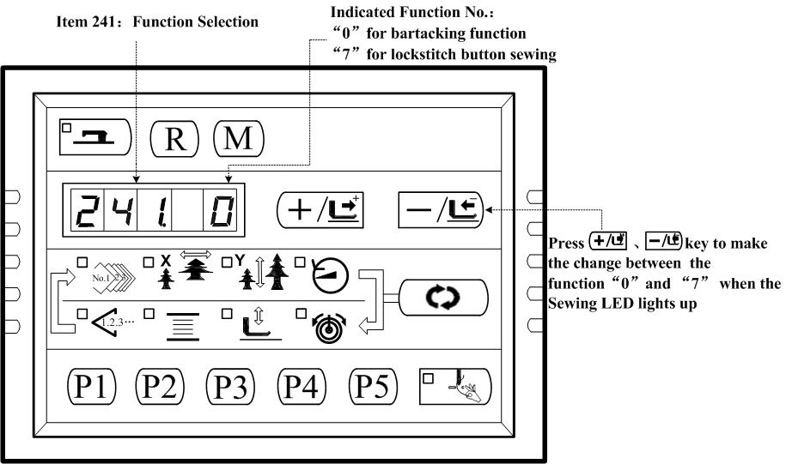
3、Press key to light up the sewing LED, and then press orkey to change the Function NO. to “7”. Press key again to save the setting and the Sewing LED goes off.
4、Press key to exit and Power off. Power on, and the machine has changed to be a lockstitch button sewing machine.

Attention: The lockstitch button sewing function need particular Presser, for details, please contact your machine agent.

4.2 Table of the Lockstitch Button Sewing Patterns
No. | Stitch Shape | Threads | Sewing Size X(mm) | Sewing Size Y(mm) | No. | Stitch Shape | Threads | Sewing Size X(mm) | Sewing Size Y(mm)
1·34 |  | 6-6 | 3.4 | 3.4 | 18·44 |  | 6 | 3.4 | 0
2·35 |  | 8-8 | 3.4 | 3.4 | 19·45 |  | 8 | 3.4 | 0
3 |  | 10-10 | 3.4 | 3.4 | 20 |  | 10 | 3.4 | 0
4 |  | 12-12 | 3.4 | 3.4 | 21 |  | 12 | 3.4 | 0
5·36 |  | 6-6 | 3.4 | 3.4 | 22 |  | 16 | 3.4 | 0
6·37 |  | 8-8 | 3.4 | 3.4 | 23·46 |  | 6 | 0 | 3.4
7 |  | 10-10 | 3.4 | 3.4 | 24 |  | 10 | 0 | 3.4
8 |  | 12-12 | 3.4 | 3.4 | 25 |  | 12 | 0 | 3.4
9·38 |  | 6-6 | 3.4 | 3.4 | 26·47 |  | 6-6 | 3.4 | 3.4
10·39 |  | 8-8 | 3.4 | 3.4 | 27 |  | 10-10 | 3.4 | 3.4
11 |  | 10-10 | 3.4 | 3.4 | 28·48 |  | 6-6 | 3.4 | 3.4
12·40 |  | 6-6 | 3.4 | 3.4 | 29 |  | 10-10 | 3.4 | 3.4
13·41 |  | 8-8 | 3.4 | 3.4 | 30·49 |  | 5-5-5 | 3.0 | 2.5
14 |  | 10-10 | 3.4 | 3.4 | 31 |  | 8-8-8 | 3.0 | 2.5
15·42 |  | 6-6 | 3.4 | 3.4 | 32·50 |  | 5-5-5 | 3.0 | 2.5
16·43 |  | 8-8 | 3.4 | 3.4 | 33 |  | 8-8-8 | 3.0 | 2.5
17 |  | 10-10 | 3.4 | 3.4

5. Update the Pattern Data by USB Flash

5.1 Pattern Data Update
1、Press key, while the Sewing LED is not illuminated, and then the Panel display . Press simultaneously, you would hear the ring of the buzzer, and then you are able to adjust the setting.
2、Press 、key to select No.62：
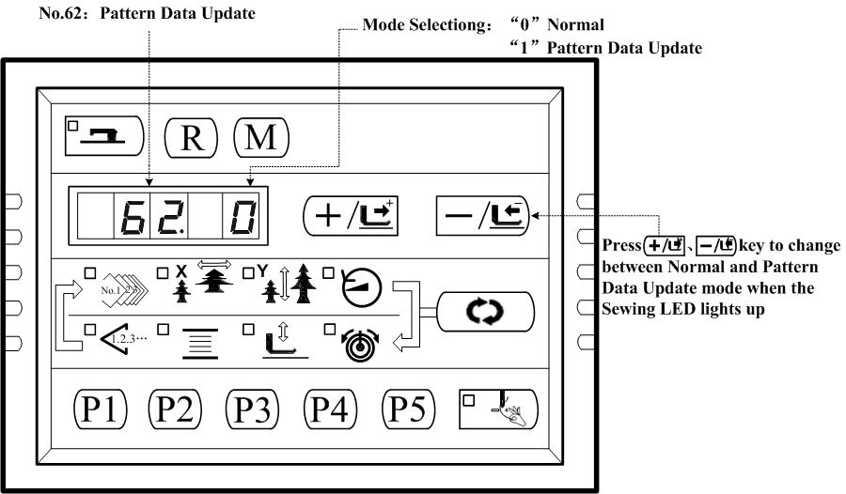
3、Press key and the Sewing LED lights up. Then press 、key to change the Mode Selection No. to be “1” (Pattern Data Update); press key again to save the setting and the Sewing LED goes off.
4、Turn OFF the power and put out the Panel form interface X7, and plug the Pattern Update Device as following:
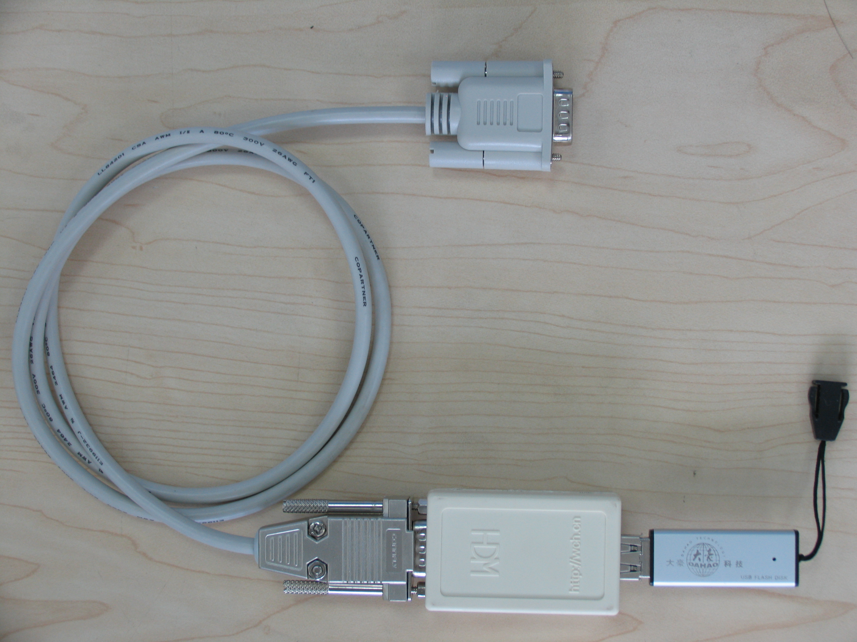
5、Store your pattern data file in the folder named ”DH” under the root directory of your USB Flash Disk. Power on and the computerized controller will automatically update your pattern data into the system memory disk., arranging form 101 to 200, and simultaneously it will backup the pattern data arranging form 101 to 200 in your old system, if there is, to a file named”DHBAK.bin”(if there is no pattern data form 101 to 200 then the DHBAK.bin file would be empty). During the updating process, please don’t pull out the Pattern Update Device. After updating, the buzzer will ring once to indicate it is successfully finished.
6、Turn OFF the power and pull out the Pattern Update Device. Plug the Panel again and Power on. Press key to display and then press 、 key to select No.201：
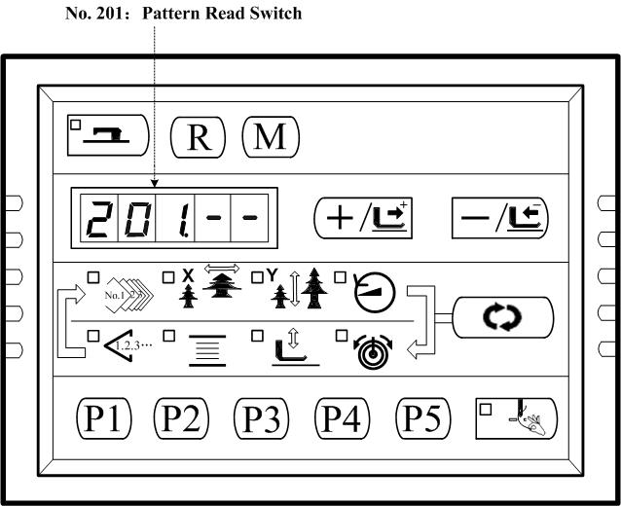
7、Press key to enter Pattern Read Switch mode and the Sewing LED lights up. “1-1” is indicated.
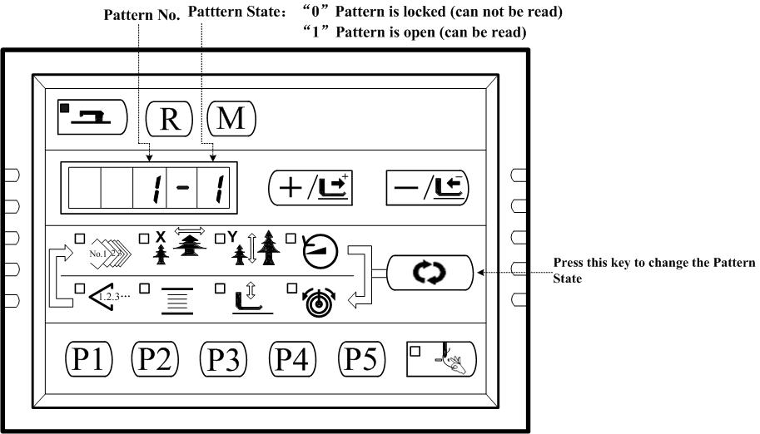
8、Press 、 key to select the pattern you want to change (for example, Pattern No.101)：
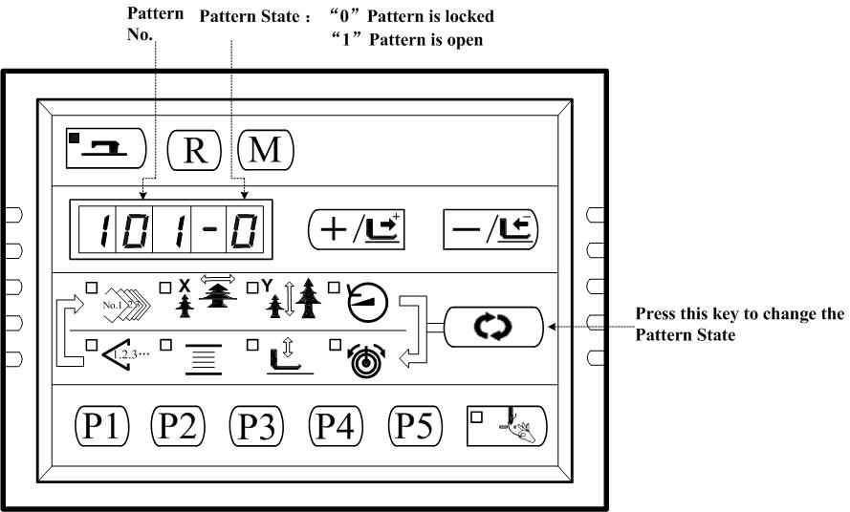
9、Press key , the indication change form “101-0” to “101-1”. It means that the Pattern No.101 is open and can be read by the control system.：
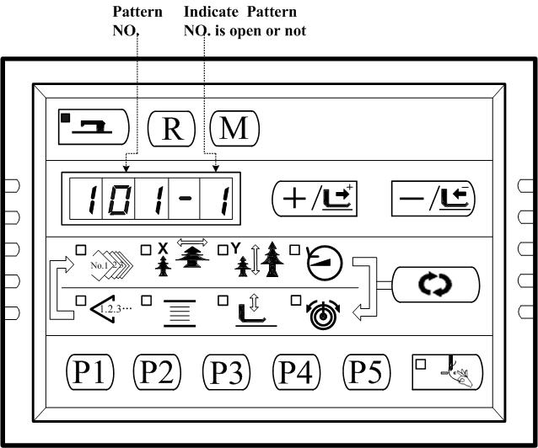
10、Press key to save the settings and Sewing LED goes off and return to Step 6；repeat the operation from step 6 to step 10 again and again to open or lock all the patterns you want.
11、Press key to go exit to Normal state.
12、Press key to select Pattern NO. 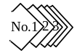, and then press 、key to get Pattern No. 101, which is opened. Then you are able to start sewing with it.

6 Appendix 1

6.1 Error List
Indication | Name of the Error | Description  of the Error | Corrective Message
E 7 | Machine Lock Error | The main shaft of the sewing machine doesn’t rotate due to some trouble. | Check the six-channel PWM signal on the MD 301 Driver Board or the responsive signal from the main servo motor encoder; turn OFF the power and remove the cause of the trouble
E 10 | Pattern No. Error | Back-up pattern No. has not been registered in the data ROM, or it is set to readout inoperative. Pattern No. is set to “0”. | Press the Reset and check the pattern No. Check the contents of memory switch No.201.
E 30 | Needle Bar Up Position Error | Needle Bar is Out of the Needle Up Position | Turn the hand pulley to return the needle bar to its UP position.
E 40 | Sewing Area Error | The sewing area is beyond the limit. | Press Reset and check the pattern and X/Y scale rate.
E 43 | Enlargement Error | The sewing pitch is beyond 10mm. | Press Reset and check the pattern and X/Y scale rate.
E 45 | Pattern Data Error | The pattern data cannot be adopted. | Turn OFF the power and check the data ROM.
E 50 | Temporary Stop | Temporary stop by operating the Reset while sewing machine is running. | Re-start or return-to-origin after thread trimming by pressing Reset.
E 221 | Grease Replenishing Warning Error | Sewing machine has stopped since the time of replenishing the designated place with grease has come. | Immediately perform replenishing with grease and set the memory switch No. 245 to “0”with Reset.
E 302 | Head Tilt Error | Head tilt detection switch is turned ON. | The sewing machine cannot be operated with the head tilted. Or you can short circuit the blue 2P coupling on SC202B with a short circuit block.
E 303 | 24V Power Supply Error | The 24V power voltage is too low | Turn OFF the power for a while and then Turn ON the power again.
E 305 | Work Clamp Foot Position Error | The work clamp foot is not in the proper position. | Turn OFF the power and check whether X9 circuit is disconnected or loose.
E 306 | Thread Clamp Position Error | The needle thread clamp device is not in the proper position. | Turn OFF the power switch and check whether CZ026 is disconnected or loose.
E 730 | Encoder Cable Not Connected | Not be able to detect ADTC signal | Turn OFF the power and check whether X5 circuit is disconnected or loose.
E 731 | Communication between the Main Board and Step Driver Board Error | Communication interferes. | Turn OFF the power and remove the cause.
E 733 | Overcurrent of Main Servo Motor | The motor stops. | Make sure that the machine is not locked, and then check weather the Encoder cable is connected well.
E 811 | Overvoltage Error | Power source voltage is beyond the specified value | Check the power source voltage
E 813 | Low Voltage Error | Power source voltage is short | Check the power source voltage
E 901 | Main Servo Motor Driver Trouble | Error form the driver is detected. | Turn OFF the power and turn ON the power again after some time.
E 903 | Stepping Motor power source trouble. | The current of the stepping driver board is over current. | Turn OFF the power and turn ON the power again after some time.
E 904 | 24V Power Supply Trouble | Over current. | Turn OFF the power and turn ON the power again after some time.
E 906 | Main Servo Motor Out of Control | Main Servo Motor Out of Control | Turn OFF the power and turn ON the power again after some time.
E 907 | X Origin Retrieval Error | X origin sensor does not change | Turn OFF the power supply and check whether X9 coupling is disconnected or loose.
E 908 | Y Origin Retrieval Error | Y origin sensor does not change | Turn OFF the power supply and check whether X9 coupling is disconnected or loose.
E 910 | Work clamp foot Origin Retrieval Error | Work clamp foot origin sensor does not change. | Turn OFF the power switch and check whether CZ025 and coupling X9 are disconnected or loose.
E 913 | Needle Thread Clamp Origin Retrieval Error | Needle thread clamp sensor does not change. | Turn OFF the power switch and check whether CZ026 and coupling X9 are disconnected or loose.
E 914 | Feed Trouble Error | Timing lag between feed and main shaft has occurred. | Turn OFF the power and check whether coupling of the main motor is loose.
E 915 | Communication Error between Panel and Main Board | Communication between the Panel and Main Board cannot be performed. | Turn OFF the power and turn ON the power again after some time Check the panel, communication cable and the main board.
E 916 | Communication Error between Main Board and Step Motor Driver MD301 | Communication between the Main Board and the Step Motor Driver MD301 cannot be performed. | Turn OFF the power and turn ON the power again after some time Check the Main Board, communication cable and the Step Motor Driver MD301.
E 943 | The Main Board and EEPROM Read/Write Error | EEPROM read or write of Main Board cannot be performed. | Turn OFF the power and turn ON the power again after some time. Check the footprint 26\27 whether be cut off.

7 Appendix 2

7.1 Installation Size of Control Box
At present, there are three kinds of installation methods for the computerized controllers of our company, which are 4-hole installation and 3-hole installation. For the detailed size, please refer to the picture as below:
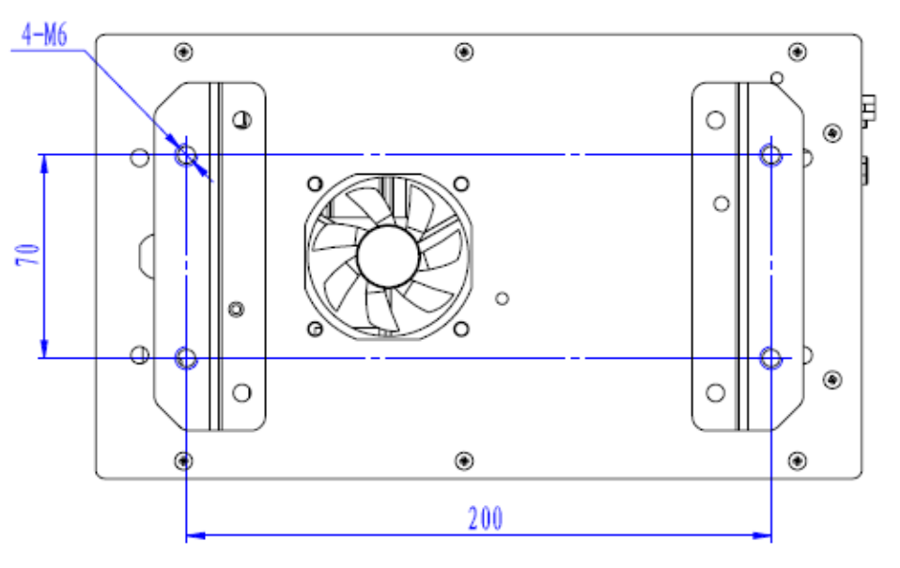
Figure 1 Size of 4-hole Installation
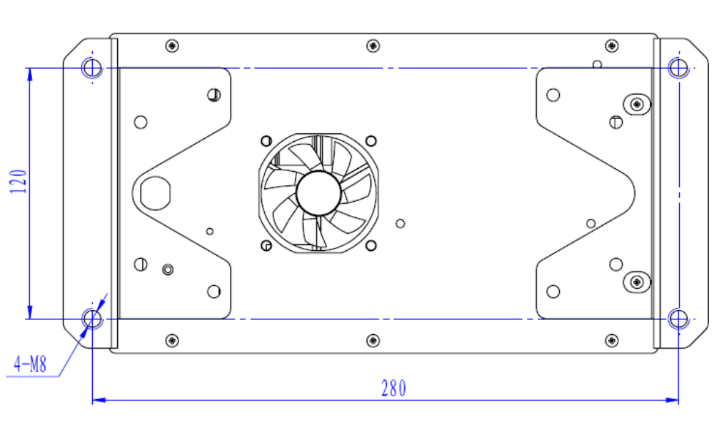
Figure 2 Size of 4-hole Installation

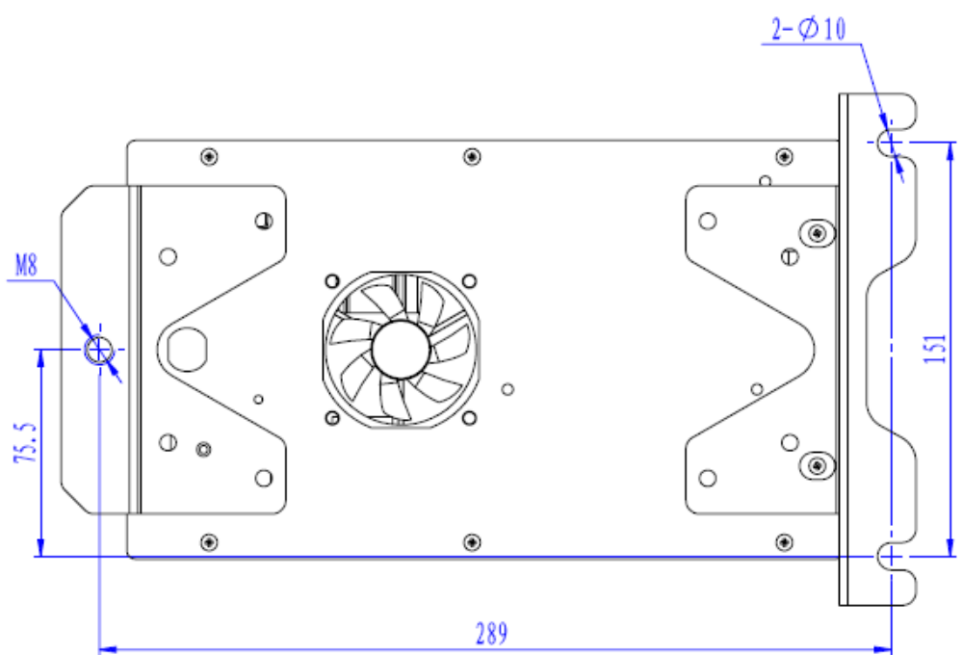
Figure 3 Size of 3-hole Installation

7.2 Installation Size of Operation Box
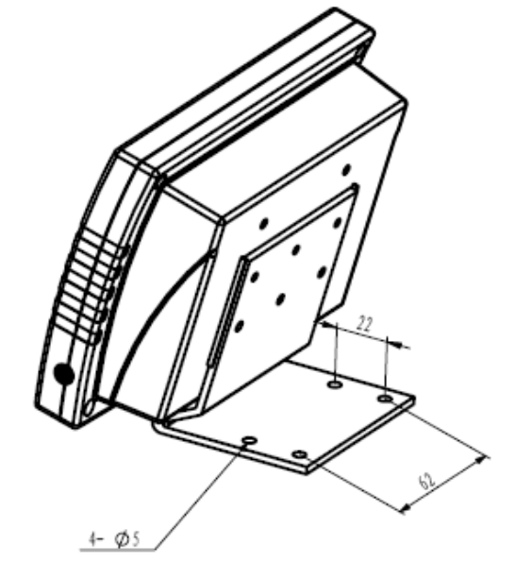

Figure 4 Installation Size of Operation Box

7.3 Diagram of Connection of the External Cable and Control Box
Please check the corresponding symbol on both the external cable and control box. Follow the symbol to make the connection.
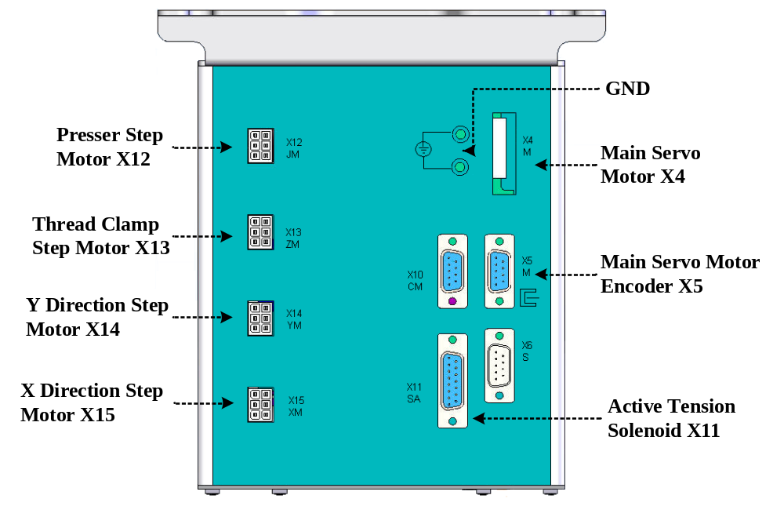
Figure 5
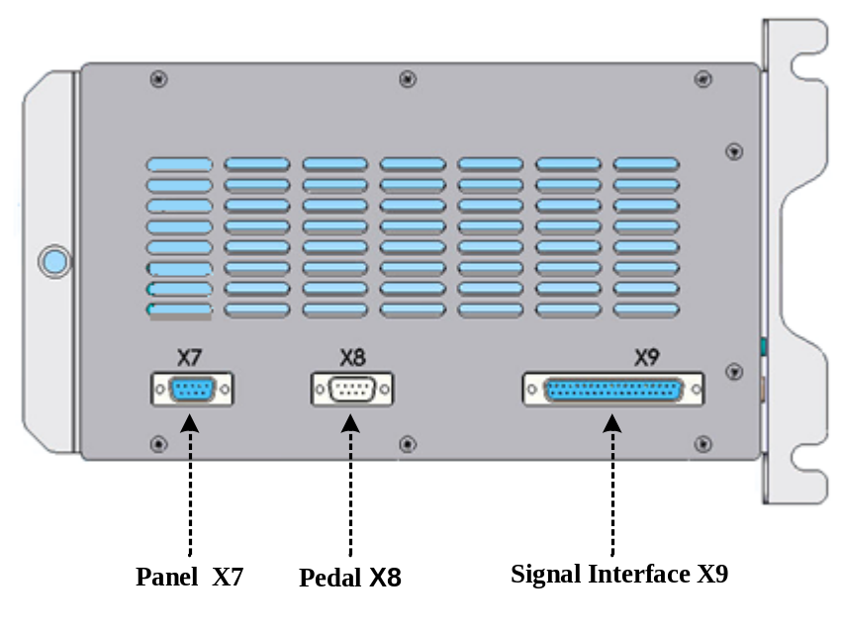
Figure 6

7.4 SC201(1900A,1903A)Control System Diagram


